Operation Tutorial for Users

2nd Edition
February 9, 2021

Table of Contents
1. Logging in to Proself 1
2. Upload / Download 4
2.1. Upload 4
2.2. Download 7
2.3. Batch Download 9
3. File delivery 11
3.1. Web Publication 12
3.1.1. Starting Web Publication 12
3.1.2. Stopping Web Publication 14
3.2. Delivery Folder 16
3.2.1. Starting a Delivery Folder 16
3.2.2. Stopping the Delivery Folder 19
3.3. Send File 20
3.3.1. The Send File function allows delivering files to external persons. 20
3.3.2. Reading templates and sending files 23
3.3.3. Stopping the Send File function 24
3.4. File Receive 26
3.4.1. Using the File Receive function to receive files from external persons 26
3.4.2. Importing templates for receiving files 28
3.4.3. Confirming uploaded files 30
3.4.4. Stopping File Receive 32
3.5. Uploads and downloads from others 34
3.5.1. Downloading files 34
3.5.2. Uploading files 36
3.5.3. Logging in using a Web Publication Password 38
3.5.4. Logging in using e-mail authentication 39
4. Other functions 42
4.1. File List 42
4.1.1. Changing the display 46
4.1.2. Search 48
4.1.3. Detail 49
4.2. Operations 50
4.2.1. Create Folder 50
4.2.2. Copy 51
4.2.3. Move 52
4.2.4. Delete 53
4.2.5. Rename 55
4.2.6. Change Attribute 56
4.2.7. Set File Expiry Date / Set Folder Expiry Date 57
4.2.8. Comment 58
4.2.9. Previous Versions 59
4.2.10. Log Download 60
4.2.11. Web Publication 60
4.2.12. Delivery Folder 61
4.2.13. Send E-mail 62
4.2.14. Show Web Link URL 65
4.3. Information 65
4.4. User Menu 66
4.4.1. Change Password 66
4.4.2. User Setting 67
4.4.3. Log Download 69
4.5. Favorite 69
4.5.1. Add Favorite 70
4.5.2. Update Favorite 73
4.5.3. Delete Favorite 74
4.6. File Search 75
4.7. Template 75
4.7.1. Add Template 75
4.7.2. Update Template 77
4.7.3. Delete Template 78
4.7.4. Send File / File Receive 79
4.8. Address book 80
4.8.1. Add Address / Update Address 81
4.8.2. Add Group / Update Group 82
4.8.3. Delete Address 84
4.8.4. Import 85
4.8.5. Export 87

Logging in to Proself
Accessing the following URL in a web browser displays the Proself Login screen. Enter your user ID and password to log in.
http://[SERVER ADDRESS]/
(Replace [SERVER ADDRESS] with an IP address or fully qualified domain name provided by your network administrator.)

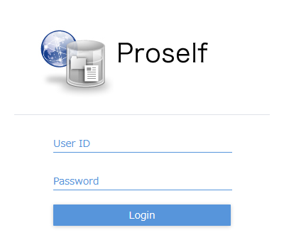
The Login screen

After a successful login, the File List screen is displayed.
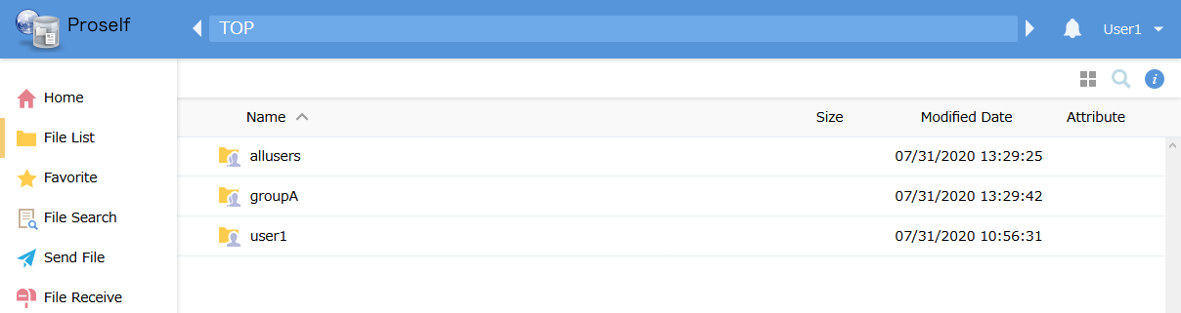
The File List screen

Depending on system administrator settings, after login the Home screen might be shown instead. In that case, click “File List” in the menu on the left or on the Home screen to display the File List screen.
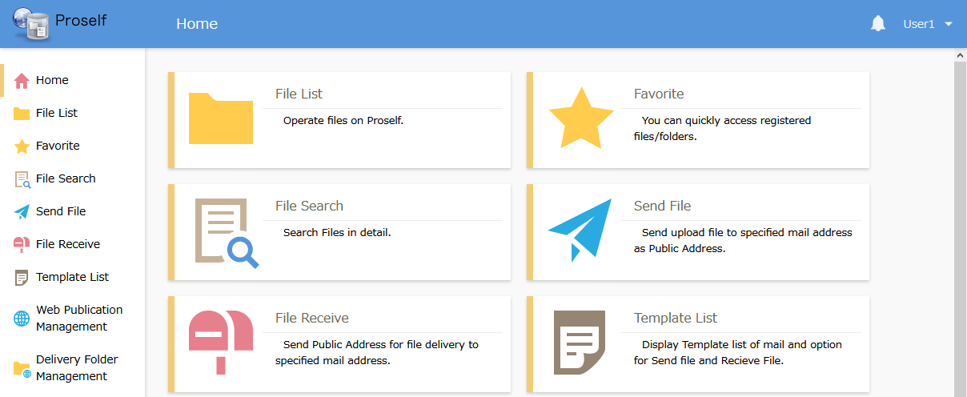
The Home screen

The File List displays two folder types, described below.
User folders and group folders can be distinguished by the differing icons on which their name is displayed.
Type | Description
User folders | A personal folder for use by the logged-in user.  This kind of folder shows just one human figure on its icon, as shown below.  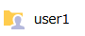
Group folders | A folder that is shared by everyone in a group, including the logged-in user.  This kind of folder shows superimposed human figures on its icon, as shown below.  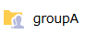

Next, click a user folder or a group folder.
This example shows the case of moving to the “user1” user folder.

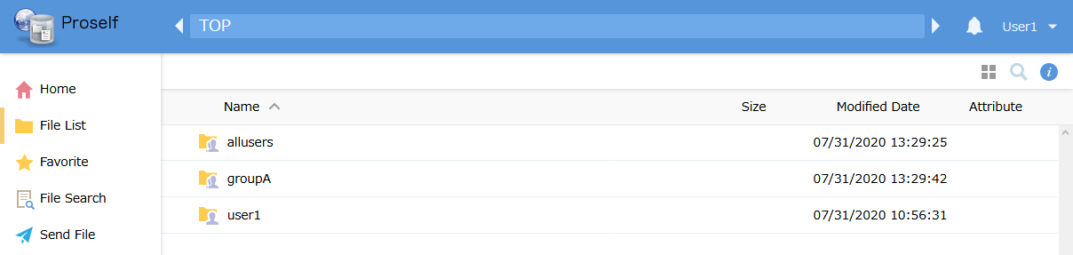
The File List screen

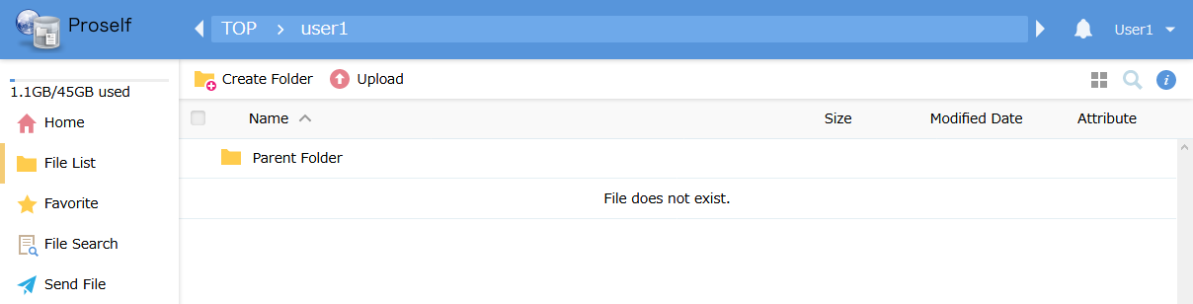
User folders

Moving to a user or group folder allows you to perform operations such as uploading or downloading files and folders. The next section describes each operation.

Upload / Download

Upload
Users can upload to Proself files and folders stored on the local computer.

Only users logged in to a user folder can upload to it, while both users logged in to a group folder and other members of the same group can upload there.
- System administrators can upload to any user or group folder.
- Note that administrator settings or the type of browser being used may prevent some uploads.

The following describes the procedure for uploading a file named “sunflower.jpg” to a user folder.

Click “Upload” in the menu at the top of the user folder.
User folders

The Upload screen is displayed. Drag the “sunflower.jpg” file stored on the local computer to the area labelled “Please drag and drop the file here.”
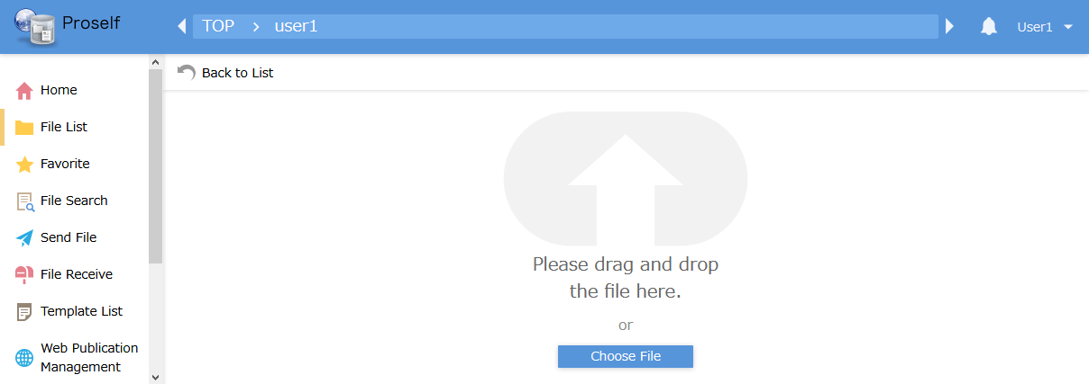
The Upload screen

You can also click the “Choose file” button on the Upload screen to choose a file using a file selection dialog.
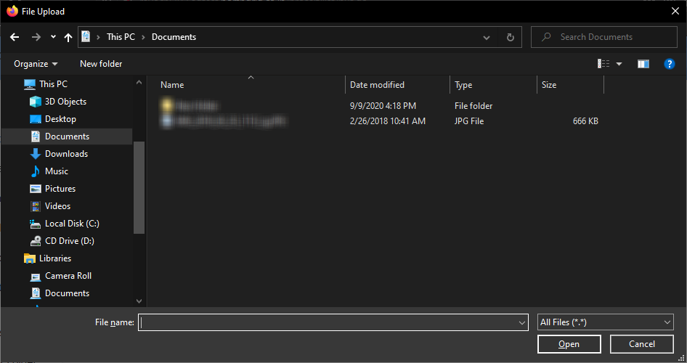
Select the file you want to upload

Click the “Upload” button to upload the file.
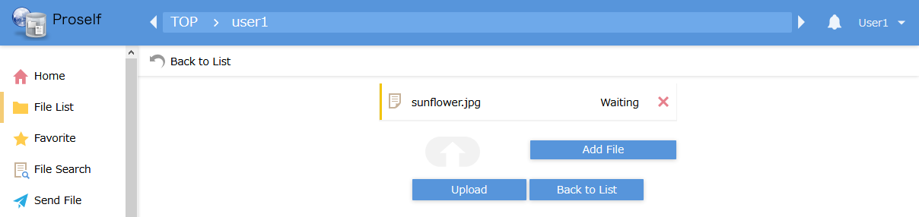
The Upload screen

- When uploading files with the same names as those already existing, a dialog will be displayed. Click “Overwrite” or “Overwrite all” to overwrite files already stored in Proself.
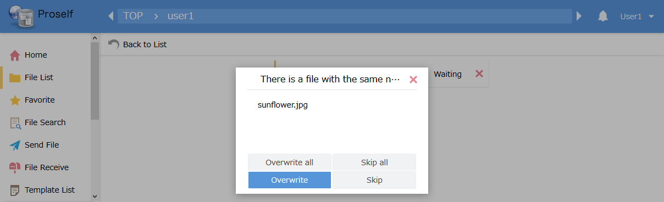
The Overwrite Confirmation dialog

A dialog is displayed when the upload is complete.
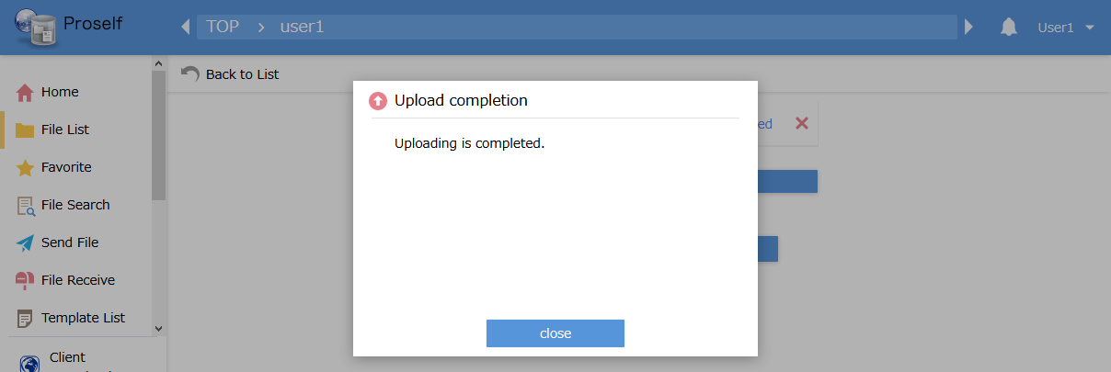
The Upload Complete dialog

Returning to the file list, you can confirm that the uploaded “sunflower.jpg” file was added.
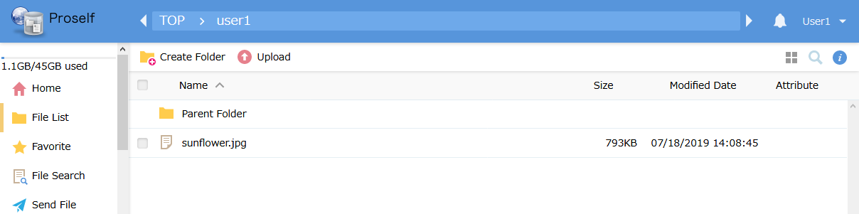
The File List screen
Note that administrator settings may prevent drag-and-drop uploads. In that case, the Upload screen will appear as below. Click the “Add File” button to select a file to upload.
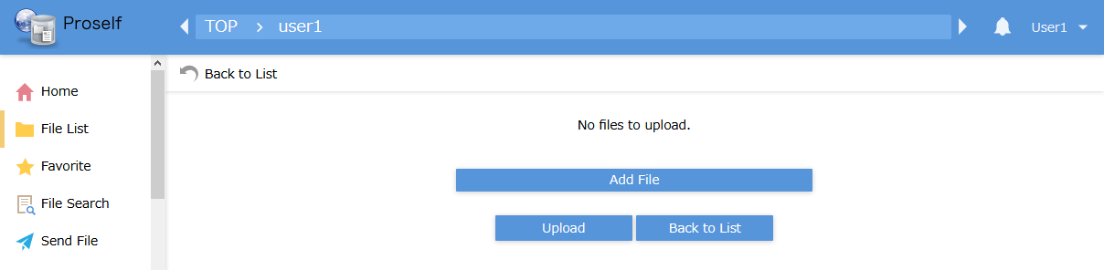
The Upload screen

If the administrator settings allow drag-and-drop uploads, you can also upload files by dragging them onto the File List screen.
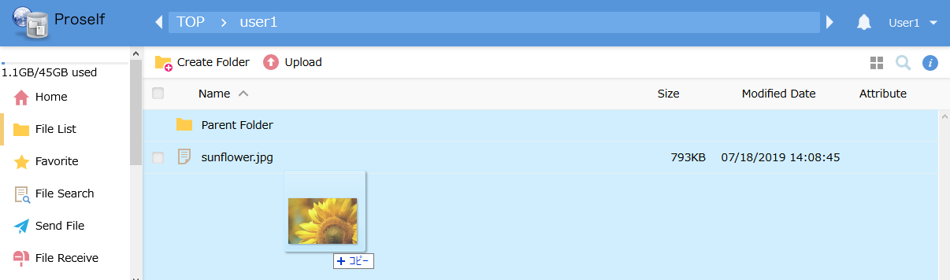
The File List screen

Download
You can download files stored in Proself to your local computer.

Files in user folders can only be downloaded by the logged-in user. Files in group folders can be downloaded by the logged-in user or by other users belonging to the same group.
- System administrators can download files stored in any user or group folder.

The following describes the procedure for downloading a file titled “wordA.docx” stored in a user folder.

Click “wordA.docx” in the file list.
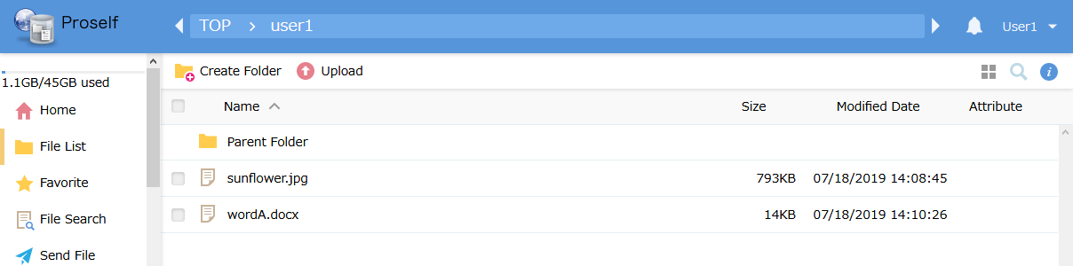
The File List screen

When a dialog is shown, select “Save File” and click the “OK” button.
- The dialog’s appearance will vary by browser. Also, some browser settings will prevent the dialog from appearing, instead automatically saving files at a predetermined location.
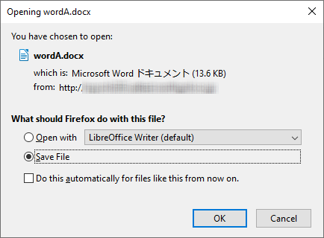
The File Save dialog

The Save Location Confirmation dialog is shown. Specify the location and click the “Save” button. In this example, we will save in the “Documents” folder.
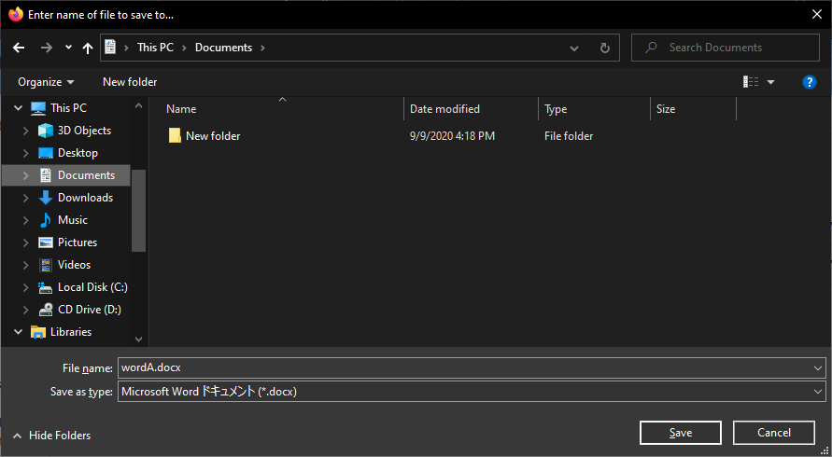
Specifying the file save location

The “wordA.docx” file is saved in the “Documents folder.”
Note: The source file remains in Proself.
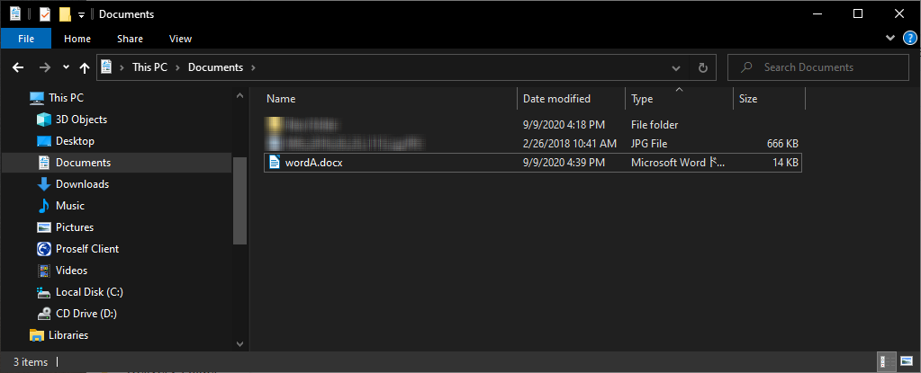
The Documents folder on the local PC

Batch Download
When downloading multiple files stored in Proself, or when downloading a folder, use the Batch Download function.
- Note that administrator settings may prevent use of this function.

In the File List screen, click the checkboxes for the files and folders you wish to download, then click “Batch Download” from the menu at the top of the screen.
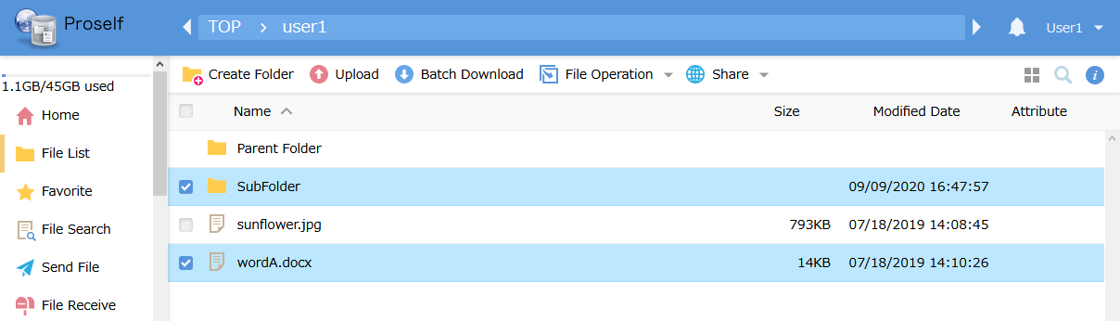
The File List screen

- You can select all displayed files and folders by clicking the checkbox at the top of the File List.
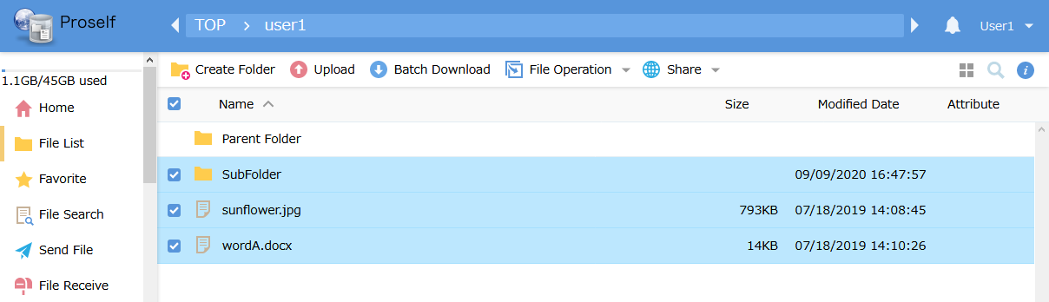
The File List screen

The Save Location Confirmation dialog is shown. Specify an appropriate save location and save the files. When performing a batch download, you can download files and folders combined into a single .ZIP file.

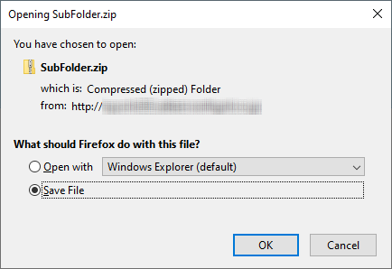
The File Save dialog

File delivery
You can use the Web Publication, Delivery Folder, Send File, or File Receive functions to deliver files to external persons not having a Proself account. These features can handle files that would be too large to send as e-mail attachments.

The following presents an overview of each function.
Function name | Overview
Web Publication | Generates a single-use URL for delivery of a file or folder stored in Proself.
Delivery Folder | Generates a single-use URL for delivery of a folder stored in Proself.
Send File | Allows simultaneous file upload, single-use URL generation, and e-mail delivery.
File Receive | Allows simultaneous folder creation, single-use URL generation, and e-mail delivery.

The following describes usage methods appropriate to each function.
- Web Publication / Delivery Folder
Use when transferring files or folders stored in Proself to persons not having an account.
- Send File / File Receive
Operations complete on a single screen, making file delivery by this method similar to using various file transfer services.

See the following section for details related to each function.

Web Publication
The following describes how to start and stop Web Publication.

Starting Web Publication
The following describes the procedure for Web Publication of a file titled “sunflower.jpg” saved in a user folder.

Click the checkbox next to “sunflower.jpg” on the File List screen, then click “Web Publication” at the top of the screen.
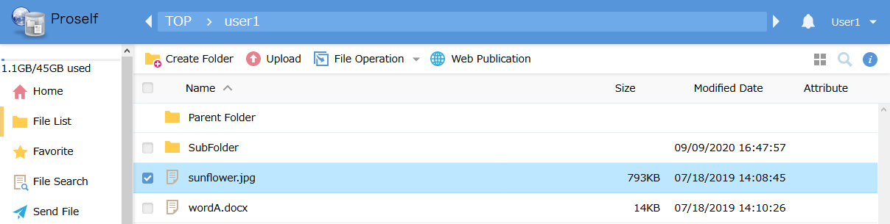
The File List screen

The Web Publication settings screen is displayed. Appropriately specify settings for number of allowed downloads , Web Publication Expiry Date, the Web Publication Password for use when accessing the published address, etc.
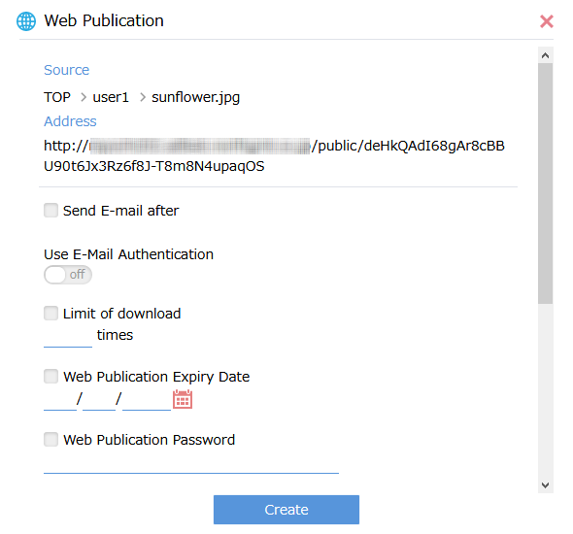
The Web Publication Settings screen

The following describes each setting.
Setting name | Description
Send E-mail after (*1) | Clicking this checkbox will cause the Send E-mail screen to be displayed after creation of the Web Publication. See “4.2.13. Send E-mail” for details regarding the Send E-mail screen.
Use E-Mail Authentication (*1) | By setting this toggle to “on,” you can require authorization by a single-use password when downloading files from the Web Publication screen.  For details, see “Proself Ver. 5—Usage Tutorial: E-mail Authorization for Web Publication, User Edition” at the following URL: (Japanese Version Only)  https://www.proself.jp/manualtutorial/list/
Limit the E-Mail Address of Public Destination (*1) | When set to “on,” only the e-mail address registered in “E-Mail Address of Public Destination” will be sent the single-use password.
E-Mail Address of Public Destination (*1) | Allows addition or deletion of e-mail addresses for sending single-use passwords for web publication.
Limit of download | When checked, web publication will be automatically stopped after the file has been downloaded the specified number of times from the Web Publication screen.
Web Publication Expiry Date | When checked, web publication will be automatically stopped after the specified expiry date.
Web Publication Password (*1) | When checked, access to the Web Publication screen requires logging in with the designated password.
The subfolder is not displayed. (*2) | Hides subfolders existing in the Web Publication screen.
Preview Only (*1) | When checked, the Web Publication screen can only be browsed; no files can be downloaded.
Setting of approval (*1) | Web publication can be performed only upon approval by the authorizer. Either “An approval request is carried out” or “Set Web Publication without carrying out an approval request” can be selected.
Public Comment | Allows designation of a comment to be displayed on the Web Publication screen.
Note 1: Depending on administrator settings, this item might not be displayed.
Note 2: This item is displayed only for Web Publication of folders.

Clicking the “Create” button performs Web Publication of the “sunflower.jpg” file. You can confirm this by the icon displayed on the File List screen.
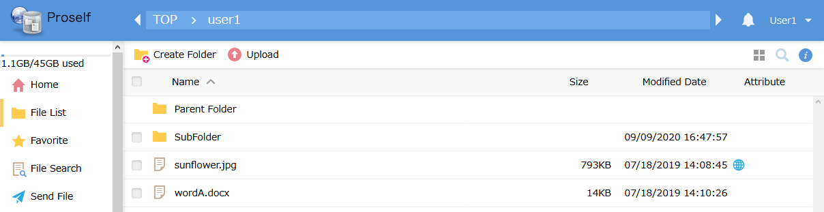
The File List screen

Next, notify the person you wish to deliver the file to (someone not having a Proself account) of the Web Publication address and password (if one is set).

Stopping Web Publication
The following describes how to stop Web Publication of files and folders that no longer need to be delivered. The procedure is as follows.

The icon in the attributes for the “sunflower.jpg” file on the File List screen indicates that the file is published on the web.
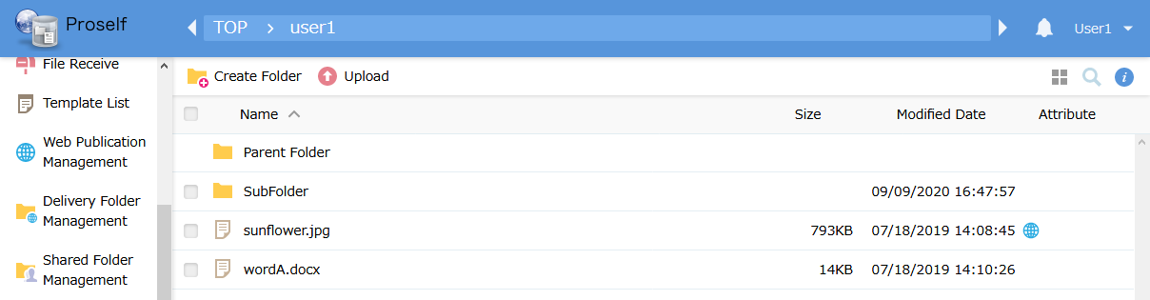
The File List screen

Clicking “Web Publication Management” in the menu on the left displays the Web Publication List. Click the checkbox for the appropriate file, then click “Stop.”
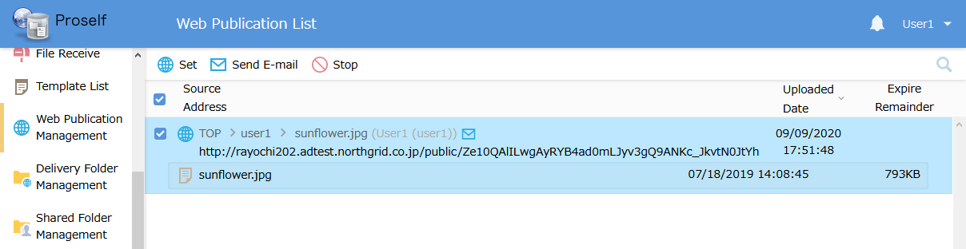
The Web Publication List screen

The Stop Publication Confirmation screen is displayed. If you want to stop publication, click “Stop.”
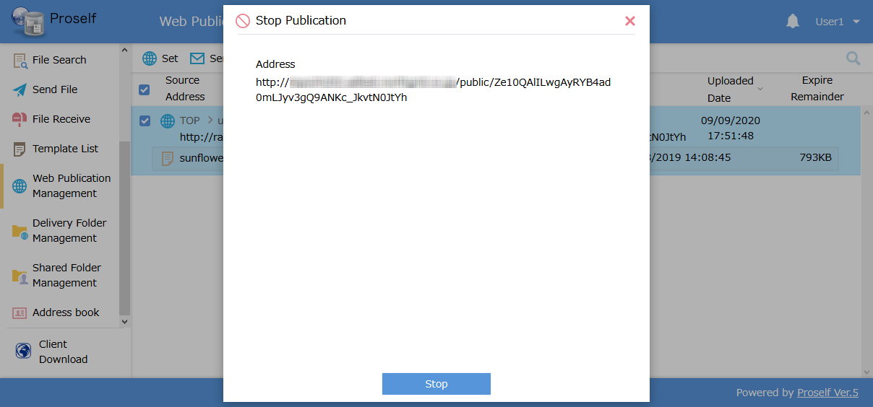
The Stop Publication Confirmation screen

The lack of an icon indicating web publication in the file list attributes confirms that processing for stopping publication is complete.
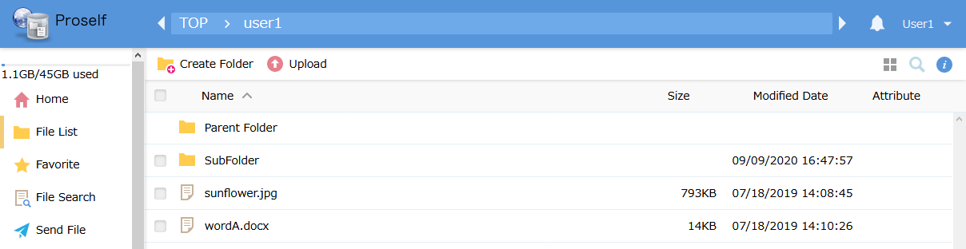
The File List screen

Delivery Folder
The following describes the details of how to start and stop Delivery Folders.

Starting a Delivery Folder
The following is the procedure for receiving in Proself a file “docA.docx” created by an external person not having a Proself account.

First, in the File List screen, create a folder named “Delivery Folder” for receiving the “docA.docx” file created by the external person.
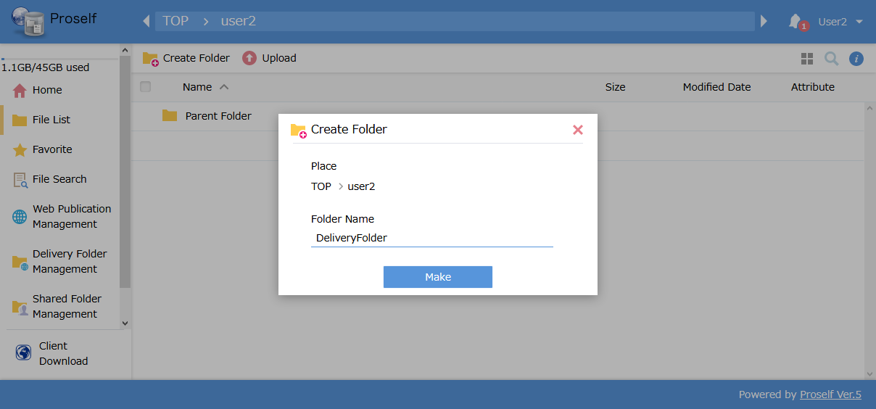
The Create Folder dialogue

Click the checkbox next to the created “Delivery Folder,” then click “Delivery Folder” in the “Share” menu at the top of the screen.
- Note that the folder will not appear in the “Share” menu if its checkbox is not checked.
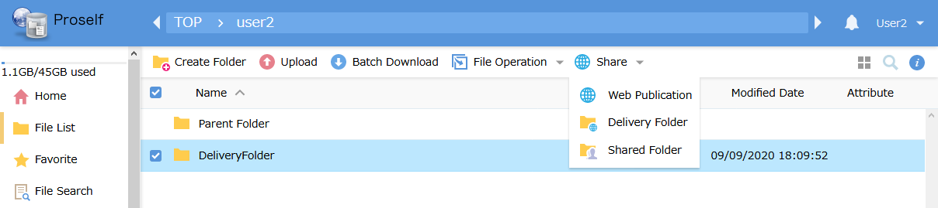
The File List screen
The Delivery Folder Settings screen is displayed, allowing you to set “Limit of upload,” “Web Publication Expiry Date,” the Web Publication Password for use when accessing the published address, etc.
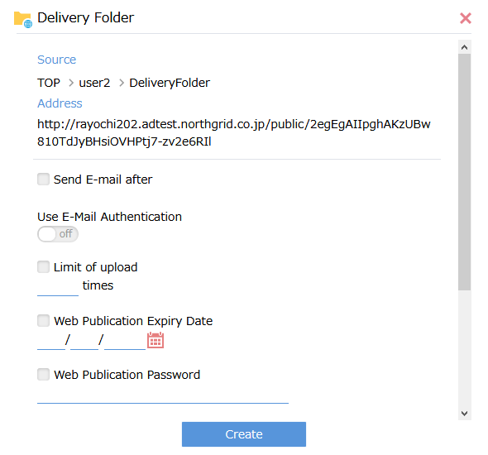
The Delivery Folder Settings screen

The following describes each setting.
Setting name | Description
Send E-mail after (*1) | If this is checked, the Send E-mail screen is displayed after Delivery Folder creation. See “4.2.13. Send E-mail” for details regarding sending e-mails.
Use E-Mail Authentication (*1) | When set to “on,” authentication by a single-use password will be required when uploading files on the Delivery Folder screen.  For details, see “Proself Ver. 5—Usage Tutorial: E-mail Authorization for Web Publication, User Edition” at the following URL: (Japanese Version Only)  https://www.proself.jp/manualtutorial/list/
Limit the E-Mail Address of Public Destination (*1) | When set to “on,” only the e-mail address registered in “E-Mail Address of Public Destination” will be sent the single-use password.
E-Mail Address of Public Destination (*1) | Allows addition or deletion of an e-mail address for sending single-use passwords for web publication.
Limit of upload | When checked, the Delivery Folder will be automatically stopped after files have been uploaded on the Delivery Folder screen the specified number of times.
Web Publication Expiry Date | When checked, the Delivery Folder will be automatically stopped after the specified expiry date.
Web Publication Password (*1) | When checked, accessing the Delivery Folder screen requires logging in with the specified password.
Upload file is not visible | Files uploaded at the Delivery Folder screen are not displayed.
Public Comment | Specifies a comment to be displayed on the Delivery Folder.
Note 1: Depending on administrator settings, this item might not be displayed.

Clicking the “Create” button creates a receiving folder, which can be confirmed by the icon added on the File List screen.
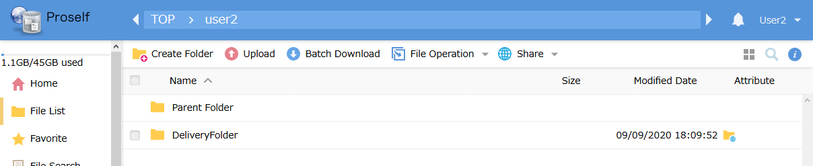
The File List screen

Next, notify the person not having a Proself account of the Web Publication address and password (if one is set), and request a file upload.

Stopping the Delivery Folder
Stop the Delivery Folder when there is no longer a need for file uploads. The procedure is as follows.

The icon in the attributes for the “Delivery Folder” on the File List screen indicates that the Delivery Folder is being published.
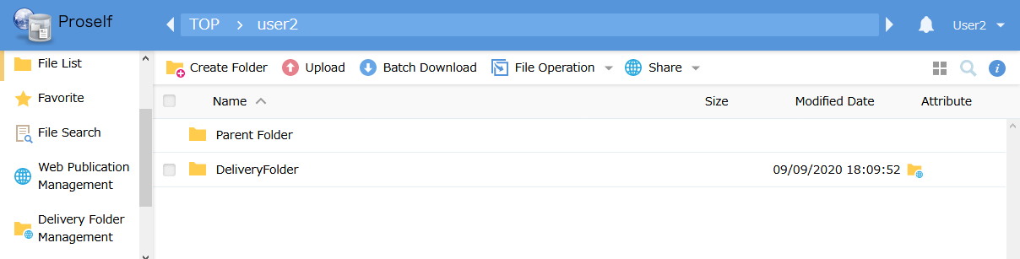
The File List screen

Clicking “Delivery Folder Management” in the menu on the left displays the Delivery Folder List screen. Click the checkbox for the appropriate folder, then click “Stop.”
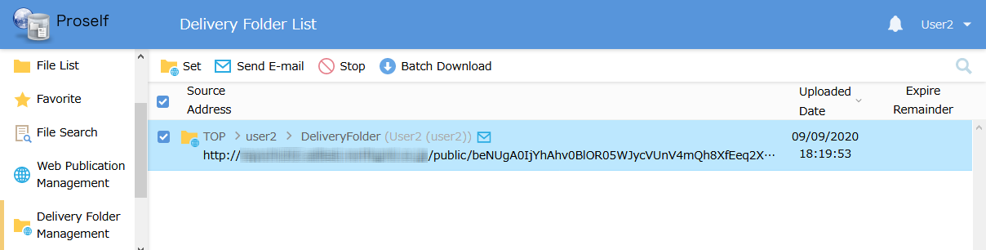
The Delivery Folder List screen

The Stop Publication Confirmation screen is displayed. If you want to stop publication, click “Stop.”
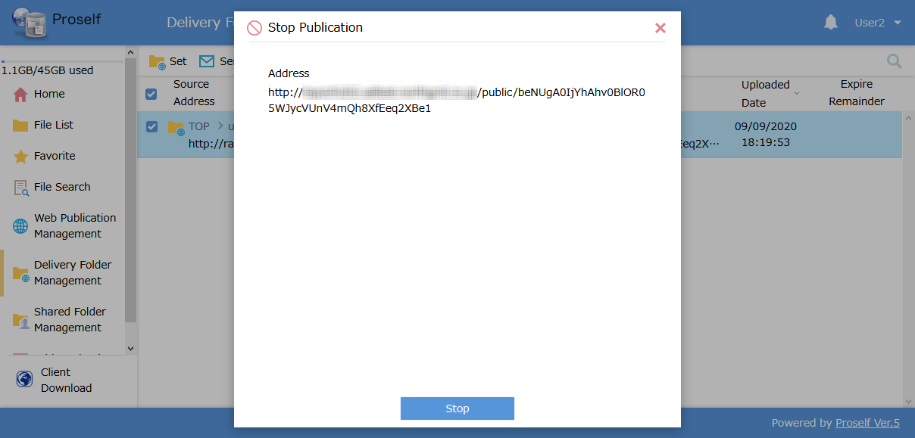
The Stop Publication Confirmation screen

The lack of an icon on the Delivery Folder in the file list attributes confirms that processing for stopping publication is complete.

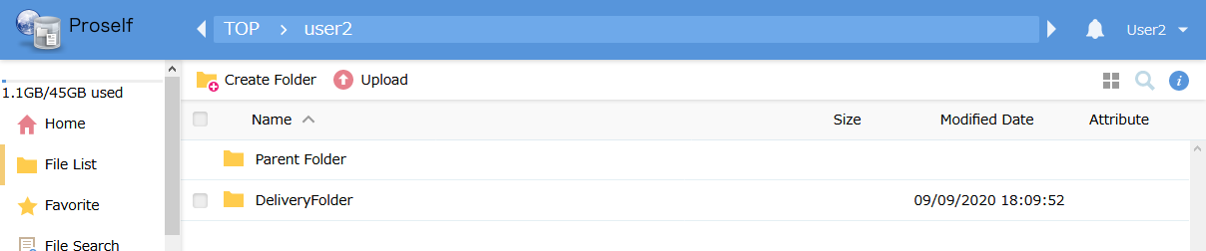
The File List screen

Send File
The following describes the details of how to start and stop the Send File function.

The Send File function allows delivering files to external persons.
The following describes the procedure for using the Send File function to send a file on the local computer to someone else.

Click “Send File” on the Home screen or at the left side of the screen.
- Depending on administrator settings, this may also be displayed on the File List screen immediately after logging in.
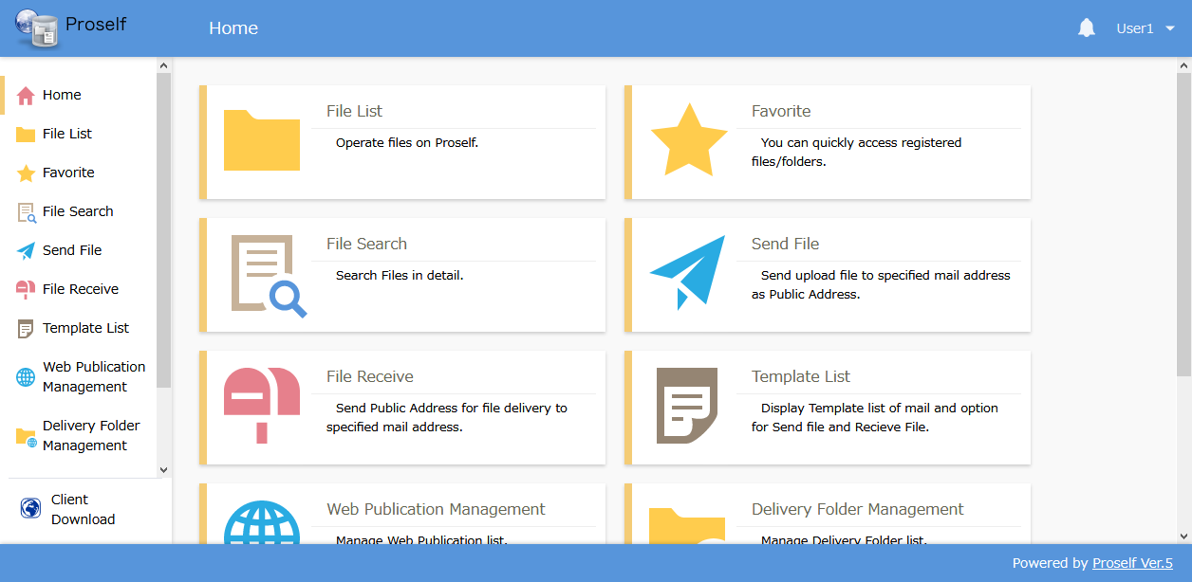
The Home screen

The Send File screen is displayed. Drag and drop the file you wish to send into the frame, or select it, then input the required items and click “Send.”
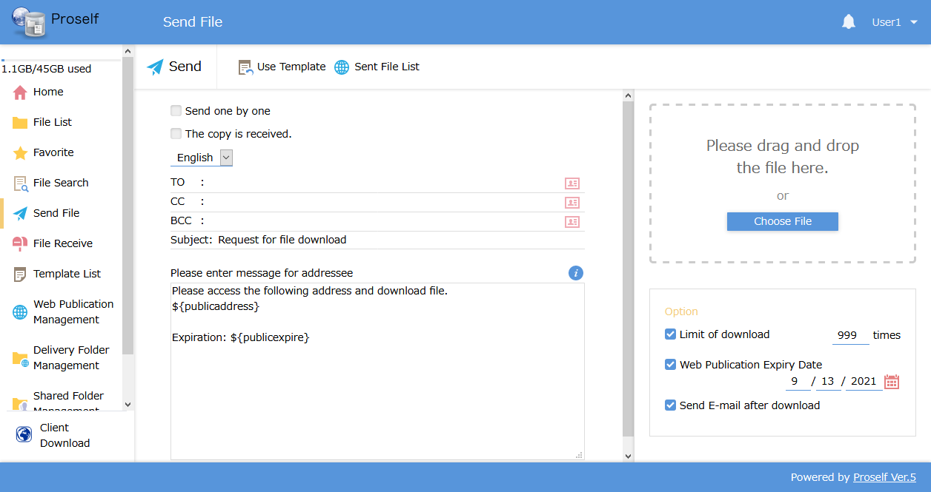
The Send File screen

The following describes each setting.
Setting name | Description
Send one by one | When checked, emails will be individually sent to each address specified in the “TO” field.
The copy is received. | When checked, a copy of the email will be sent to your e-mail address.
TO/CC/BCC | Input e-mail addresses in the TO, CC, and BCC fields.
Subject | A different subject line can be input here. (A subject line specified by the system administrator is input by default.)
Message | Enter a body message. (A body message specified by the system administrator is input by default.)  - If a default body message is displayed, be careful not to delete the “${publicaddress}” tag; doing so will prevent the download URL from being included in the received e-mail.
Limit of download (*1) | When checked, web publication will be automatically stopped after the file has been downloaded the specified number of times from the Web Publication screen.
Web Publication Expiry Date (*1) | When checked, web publication will be automatically stopped after the specified expiry date.
Send E-mail after download (*1) | When the file is downloaded from the Web Publication screen, a notification is sent to the user who performed the Send File settings.
Note 1: Depending on administrator settings, some setting items might not be displayed, or may not be user changeable.

Administrator settings may also prevent file delivery without authorization. For details, see “Proself Ver. 5—Usage Tutorial: Authorization for Web Publication, User Edition” at the following URL: (Japanese Version Only)
https://www.proself.jp/manualtutorial/list/

Reading templates and sending files
Files can be sent after reading a previously created template.
Note: See “4.7. Template” for details regarding templates.

Click “Use Template” at the top of the Send File screen.
The Send File screen

The Template List dialog is shown. Select the template name you wish to apply, and click “Apply.”
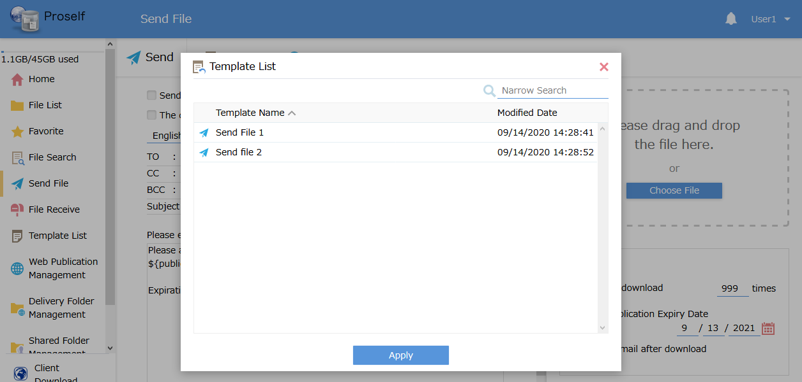
The Template List dialog
The settings defined in the template will be automatically applied. Make any changes necessary, then click “Send.”
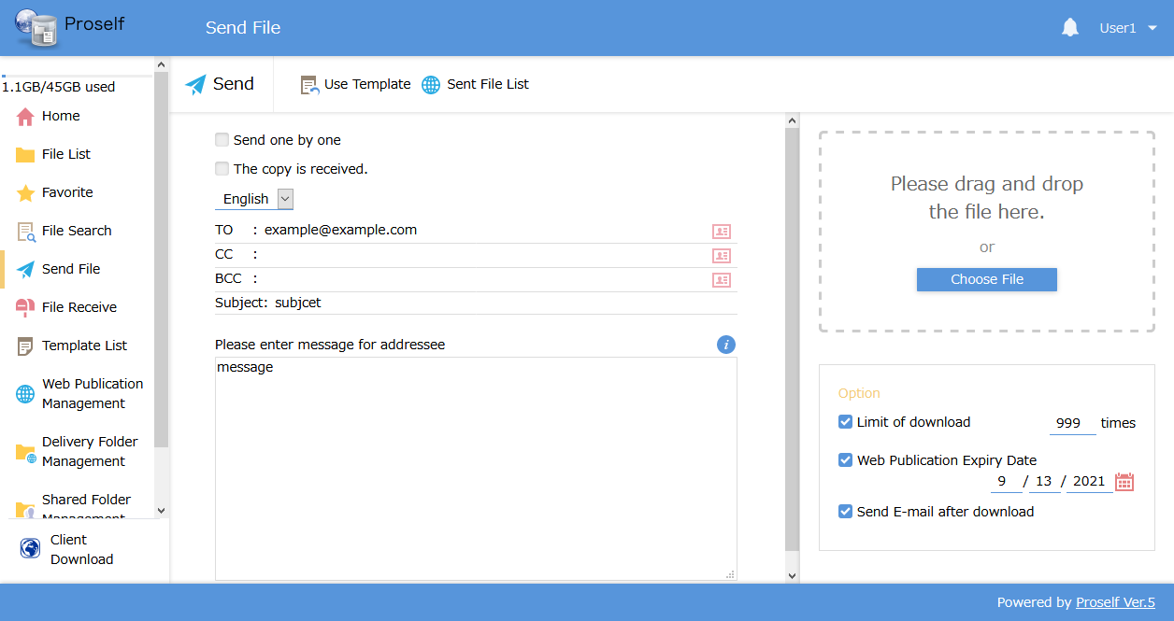
The Send File screen

Stopping the Send File function
When you wish to stop delivery of a file that was sent inadvertently, or when you wish to cease publication of a file before its expiry date, use the following procedure to stop the Send File function. After doing so, the sent file will be deleted from Proself.

Click “Send File List” on the Send File screen.

The Send File screen

A list of files currently being published is displayed. Click the checkbox next to the URL you want to stop publishing, then click “Stop.”
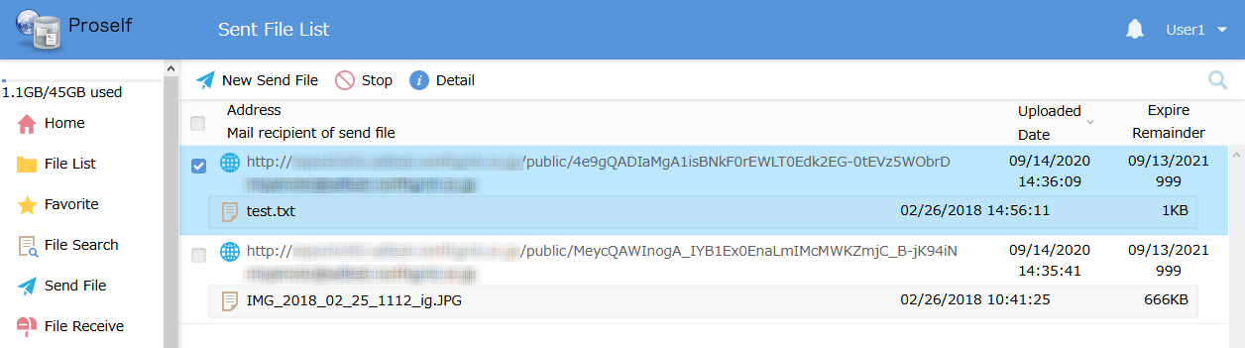
The Send File List screen

The Stop Publication Confirmation screen is displayed. If you want to stop publication, click “Stop.”
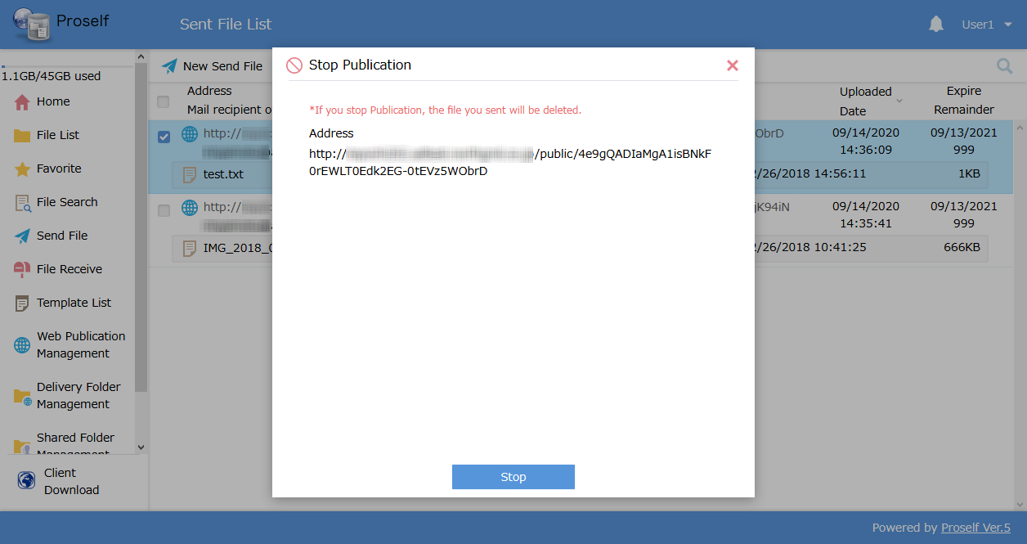
The Stop Publication Confirmation screen

You can confirm that processing for stopping publication is complete when the selected published URL is deleted from the Send File List.
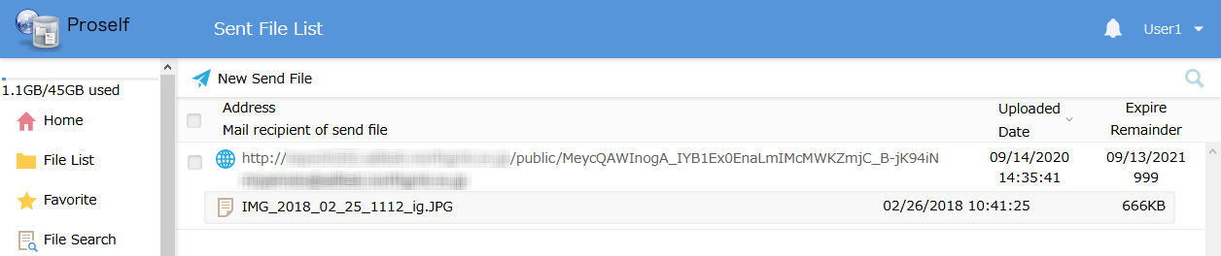
The Send File List screen

File Receive
This section describes the details of starting and stopping the File Receive function.

Using the File Receive function to receive files from external persons
The following describes the procedure for using the File Receive function to notify recipients of a file upload URL by email.

Click “File Receive” from the Home screen or at the left of the screen.
- Depending on administrator settings, this may also be displayed on the File List screen immediately after logging in.
The Home screen

On the File Receive screen, enter the e-mail address of the person you wish to receive a file from, along with any other necessary settings, then click the “Send” button.
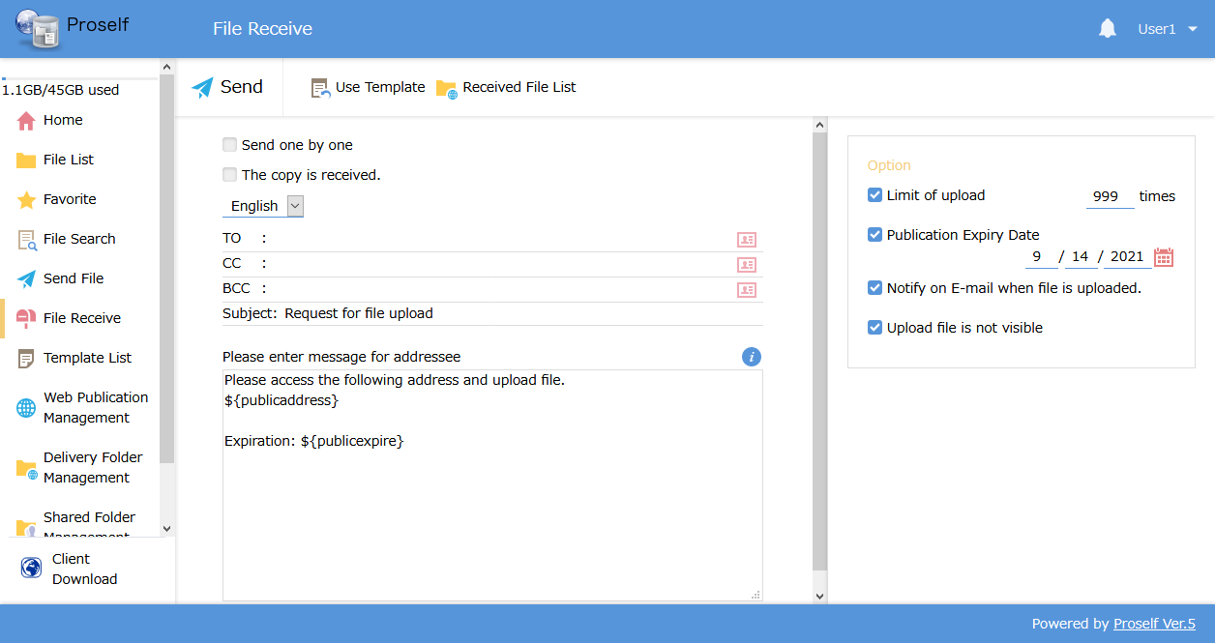
The File Receive screen

The following describes each setting.
Setting name | Description
Send one by one | When checked, emails will be individually sent to each address specified in the “TO” field.
The copy is received. | When checked, a copy of the email will be sent to your e-mail address.
TO/CC/BCC | Input e-mail addresses in the TO, CC, and BCC fields.
Subject | A different subject line can be input here. (A subject line specified by the system administrator is input by default.)
Message | Enter a body message. (A body message specified by the system administrator is input by default.)  Note: If a default body message is displayed, be careful not to delete the “${publicaddress}” tag; doing so will prevent the upload URL from being included in the received e-mail.
Limit of upload (*1) | When checked, the Delivery Folder will be automatically stopped after files have been uploaded on the Delivery Folder screen the specified number of times.
Publication Expiry Date (*1) | When checked, the Delivery Folder will be automatically stopped after the specified expiry date.
Notify on E-mail when file is uploaded. (*1) | When a file is uploaded to the Delivery Folder screen, a notification is sent to the user who performed the File Receive settings.
Upload file is not visible (*1) | Files uploaded at the Delivery Folder screen are not displayed.
Note 1: Depending on administrator settings, some setting items might not be displayed, or may not be user changeable.

Importing templates for receiving files
Files can be received after importing a previously created template.
Note: See “4.7. Template” for details regarding templates.

Click “Use Template” at the top of the File Receive screen.
The File Receive screen

The Template List dialog is shown. Select the template name you wish to apply, and click “Apply.”
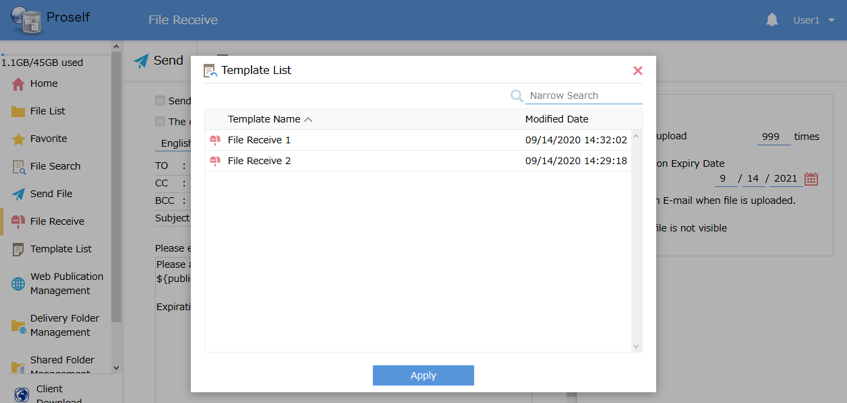
The Template List dialog

The settings defined in the template will be automatically applied. Make any changes necessary, then click “Send.”
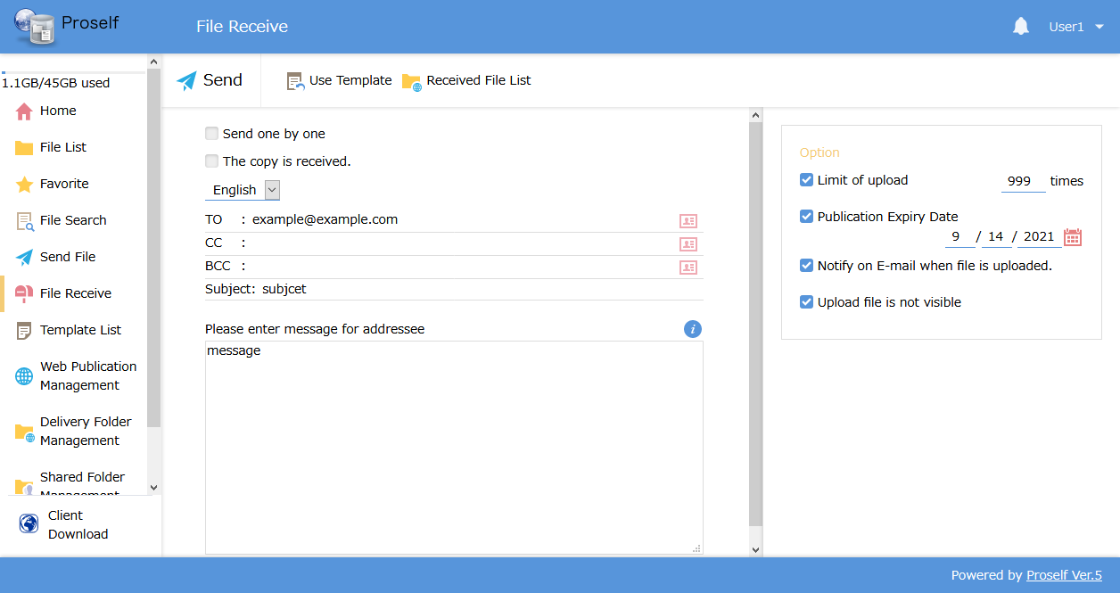
The File Receive screen

Confirming uploaded files
The following procedure allows you to confirm files external persons have uploaded via the File Receive function.

Click “File Receive” on the Home screen or at the left of the screen.
The Home screen

After the File Receive screen is displayed, click “Received File List” at the top of the screen.
The File Receive screen

A list of files uploaded to the Received File List is displayed. Click a file and save it wherever you wish.
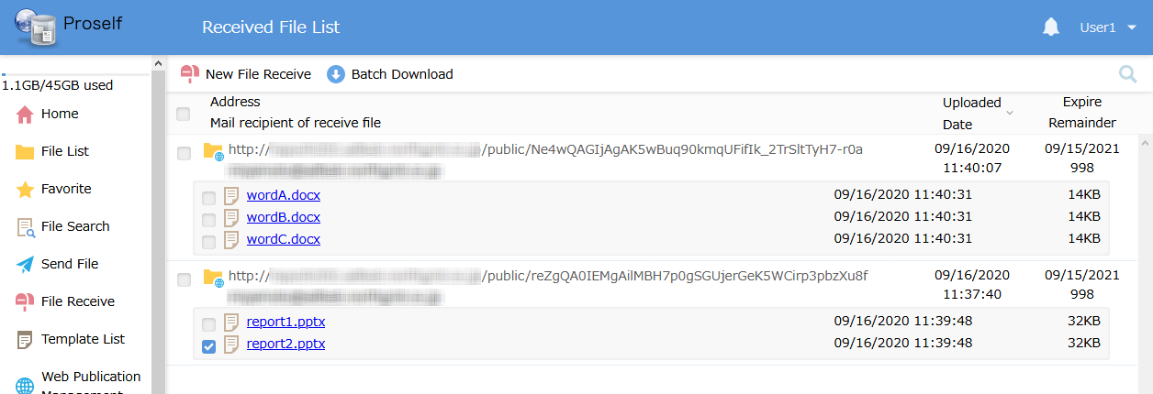
The Received File List screen

After clicking the checkbox next to a published URL, or those next to multiple files and folders, you can click “Batch Download” at the top of the screen. When performing a batch download, you can download files and folders combined into a single .ZIP file.
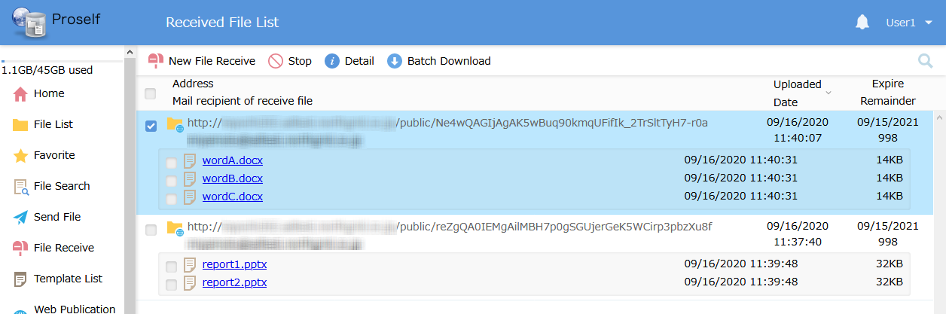
The Received File List screen

Stopping File Receive
When you no longer have a need for receiving files, perform the following procedure to stop the File Receive function. After doing so, received files are deleted from Proself.

Click “Received File List” on the File Receive screen.
The File Receive screen

The currently published Received File List is displayed. Click the checkbox next to the published URL you wish to stop, then click “Stop” at the top of the screen.
The Received File List screen

The Stop Publication Confirmation screen is displayed. If you want to stop publication, click “Stop.”
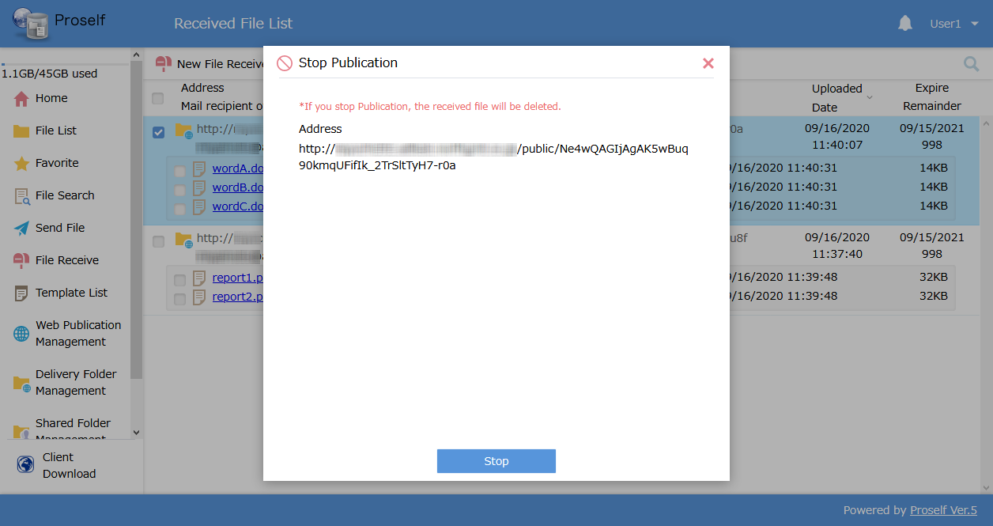
The Stop Publication Confirmation screen

You can confirm that processing for stopping publication is complete when the selected URL is deleted from the Received File List.
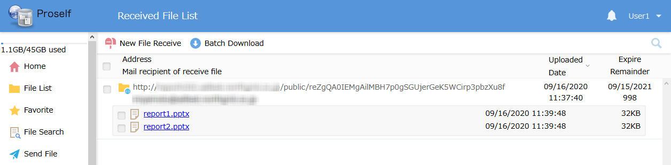
The Received File List screen

Uploads and downloads from others
Using a web browser to access a published URL issued by the Web Publication, Delivery Folder, Send File, or File Receive functions allows others to upload or download files.

The following sections describe each operation.

Downloading files
The following procedure allows persons receiving notification of a published URL issued by the Web Publication or Send File functions to download files.

Use a web browser to access the URL included in the received e-mail.
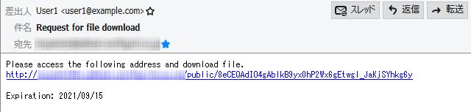
The received e-mail

The Web Publication screen is displayed. Click the file to be downloaded and save it wherever you wish.
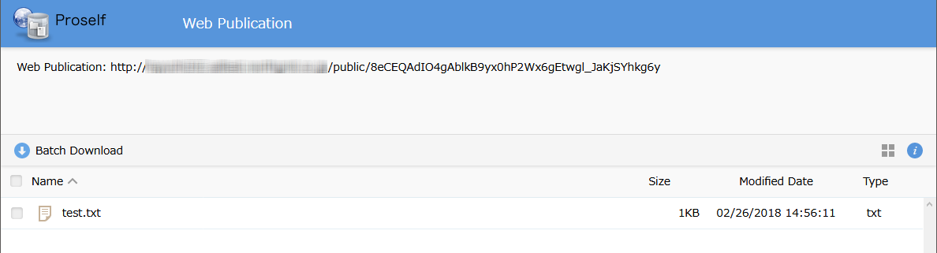
The Web Publication screen

Clicking the checkboxes next to multiple files allows using the “Batch Download” function.
Note: Administrator settings may make the Batch Download function unavailable.

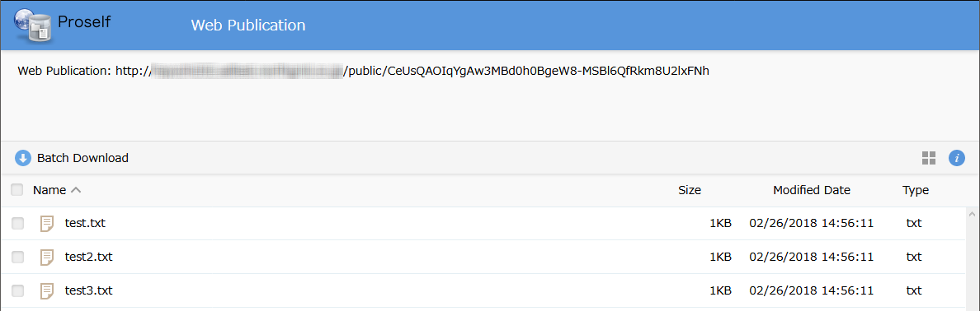
The Web Publication screen: Batch Download

If Web Publication is set for viewing only, the following fixed thumbnail display is shown, and only previews are possible. Files cannot be downloaded.
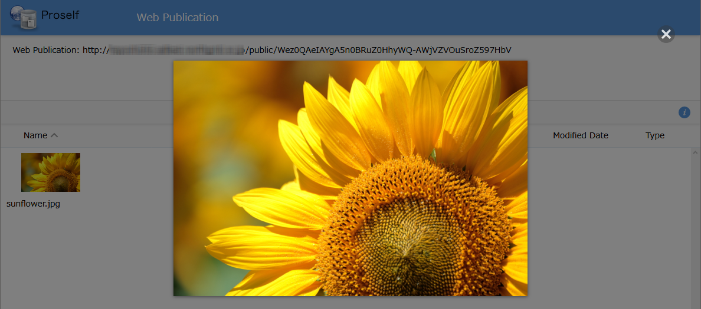
The Web Publication screen (previews only)

Note that when accessing the URL, administrator settings may require logging in using a Web Publication Password, e-mail authentication, or a random password.

For details, see “3.5.3. Logging on using a Web Publication Password” and “3.5.4. Logging on using e-mail authentication.”

Uploading files
The following procedure allows persons receiving notification of a published URL issued by the Delivery Folder or File Receive functions to upload files.

Use a web browser to access the URL included in the received e-mail.
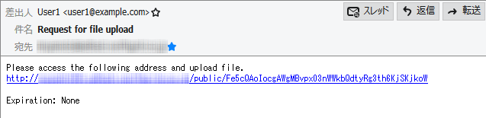
The received e-mail

The Delivery Folder screen is displayed. Click “Upload.”
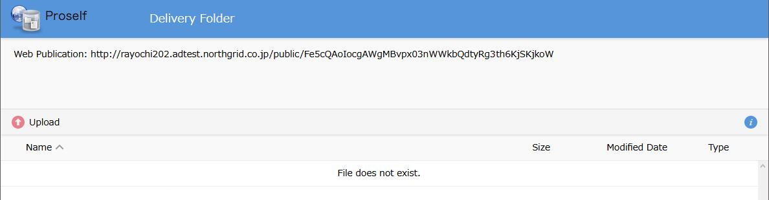
The Delivery Folder screen

A screen allowing selection of the file to be uploaded is shown.
Drag and drop a file into the area labelled “Please drag and drop the file here.” Clicking the “Choose File” button on the Upload screen allows uploading a file from a selected location.
- Note that administrator settings may prevent drag and drop operations.

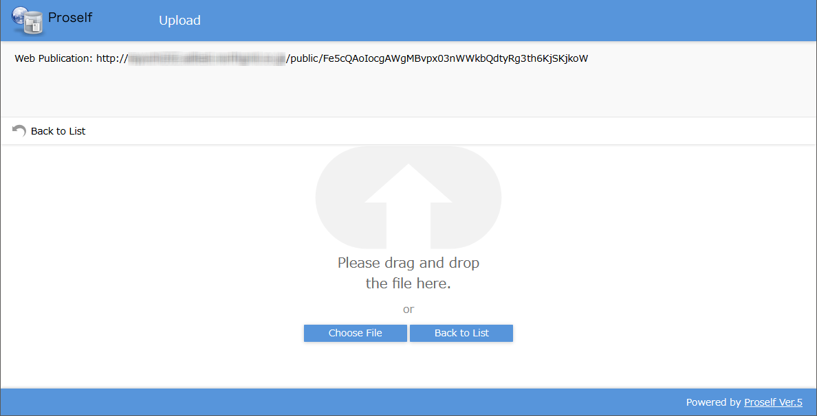
The Upload screen

Click the “Upload” button to upload the file. You can add an appropriate message in the comment field.
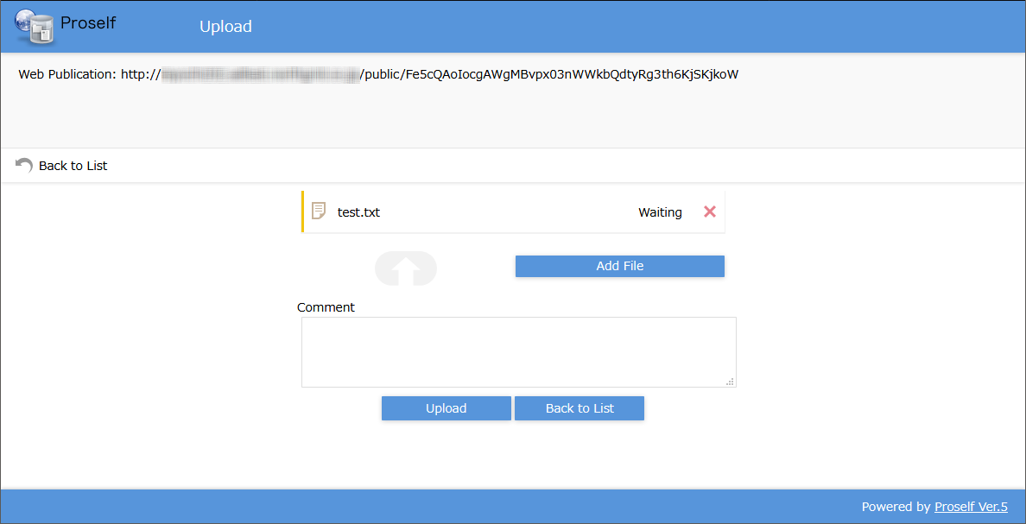
The Upload screen

A dialog is displayed when the upload is complete.
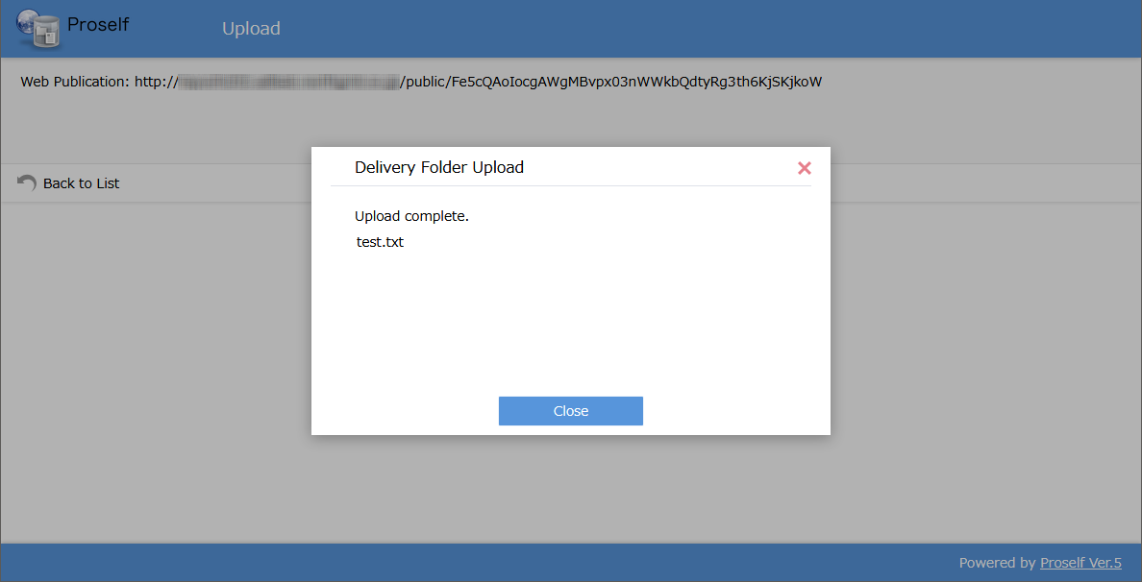
The Upload Complete dialog

After the upload is complete, you can confirm that the file is displayed on the Delivery Folder screen.
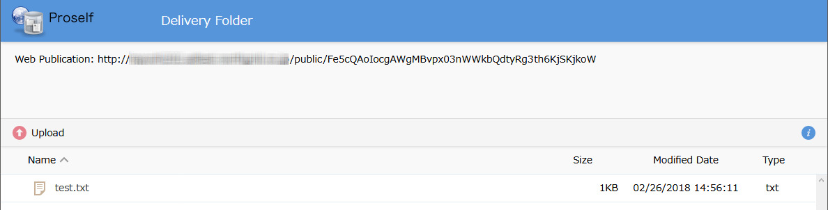
The Delivery Folder screen

Note that when accessing the URL, administrator settings may require logging in using a Web Publication Password, e-mail authentication, or a random password.

For details, see “3.5.3. Logging on using a Web Publication Password” and “3.5.4. Logging on using e-mail authentication.”

Logging in using a Web Publication Password
When using a web browser to access the URL, the Login screen may be displayed.
In that case, input the password delivered by a separate e-mail from the user receiving the file, then click the “Login” button.
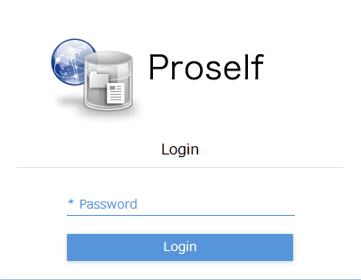
The Login screen when accessing a published URL

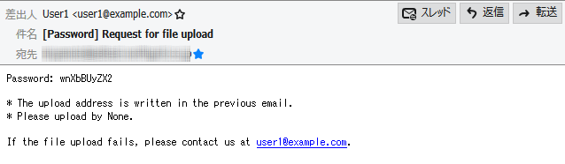
Example password e-mail

After a successful login, the Web Publication or Delivery Folder screen is displayed.

Note that user settings for the Web Publication or Delivery Folder functions may also require logging in using e-mail authentication.

See the next section for details.

Logging in using e-mail authentication
If the E-mail Authentication screen is displayed when accessing a published URL created by the Web Publication or Delivery Folder functions, enter your e-mail address, then click the “Get Password” button.
- The screen below is the E-mail Authentication screen for the Web Publication function.
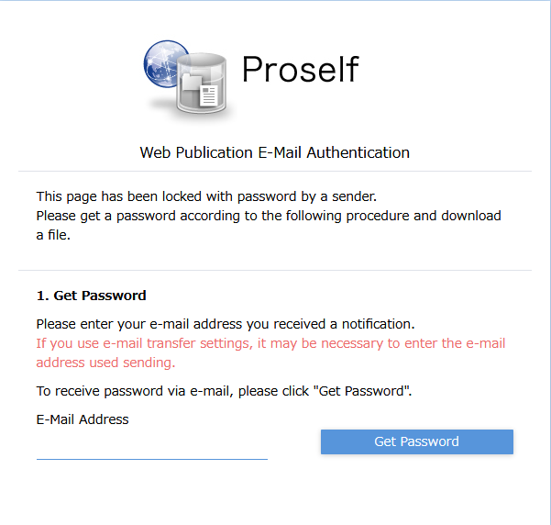
The E-mail Authentication Login screen
(for the Web Publication function)

The Password Entry screen is shown, and an e-mail containing a single-use password will be sent. Enter the password on this screen and click the “Submit Password” button.
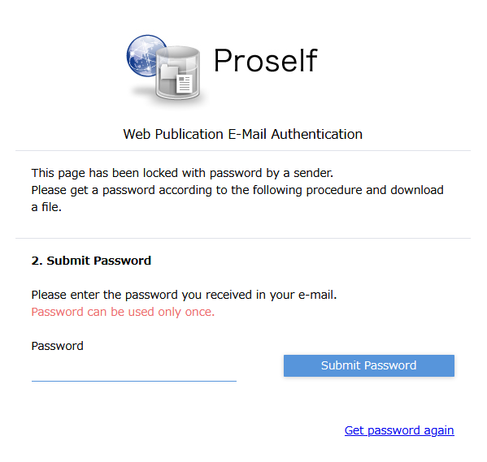
The E-mail Authentication Login screen
(for the Web Publication function)

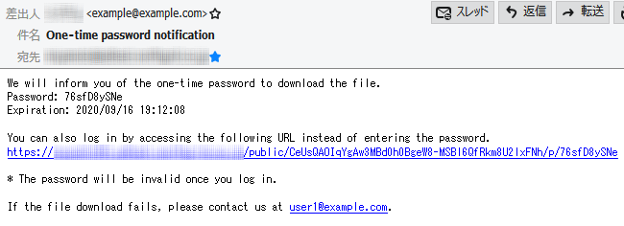
A single-use password e-mail (for the Web Publication function)

After successful authentication, the Web Publication or Delivery Folder screen is shown.

Other functions

File List
The File List screen show files and folders saved by the user. From this screen, you can perform various operations on files and folders or make changes to individual user settings and display settings, etc.
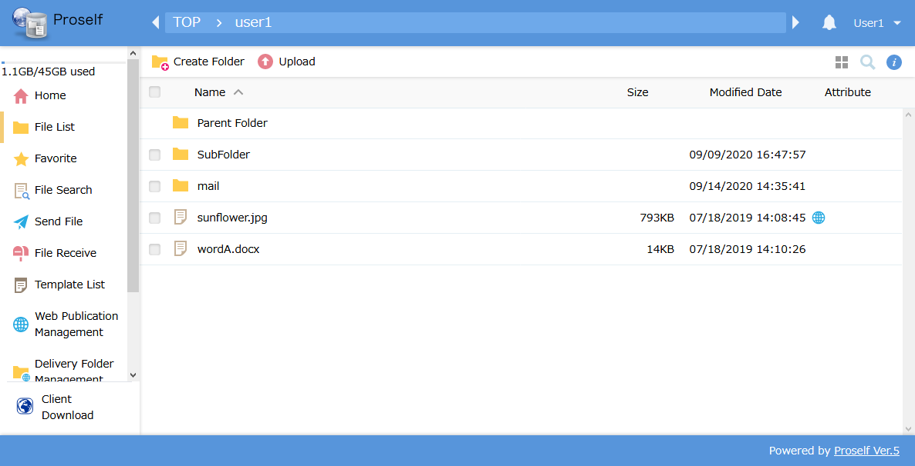
The File List screen

The area surrounded by the red box on the left side of the screen below shows the current storage for user and group folders, their storage limits, and menu items for each function. Clicking a menu item takes you to that function’s screen.
- If administrator settings do not limit storage capacity, current disk usage and total capacity of the server on which Proself is installed is displayed.
- Note that administrator settings may prevent usage and display of some menu items.
The File List screen

The area surrounded by the red box at the top of the screen below shows a breadcrumb trail to the current folder, along with a bell icon indicating any notifications and the name of the currently logged-in user.
Clicking on an item in the breadcrumb trail takes you that folder. Clicking the user name allows you to change user settings.
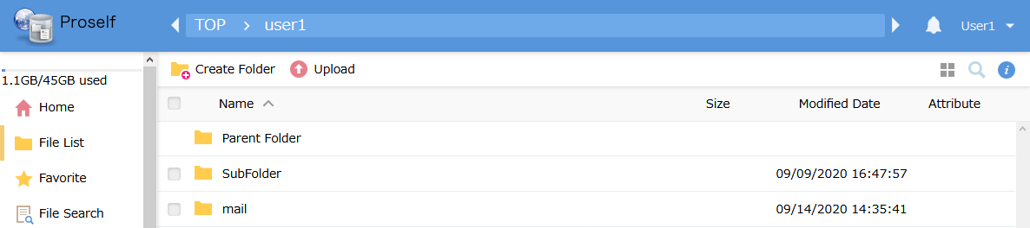
The File List screen

See “4.3. Information” for details regarding notifications, and “4.4. User Menu” regarding user settings.

The area surrounded by the red box in the screen below shows a menu allowing operations that can be performed for the current folder.
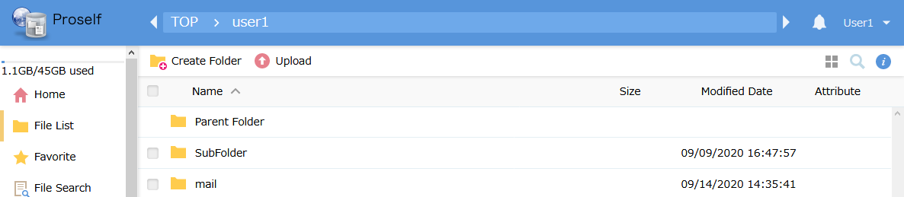
The File List screen

See “4.2. Operations” for details.

The area surrounded by the red box in the screen below shows, from the left, icons for changing the display, searches, and detailed information display.
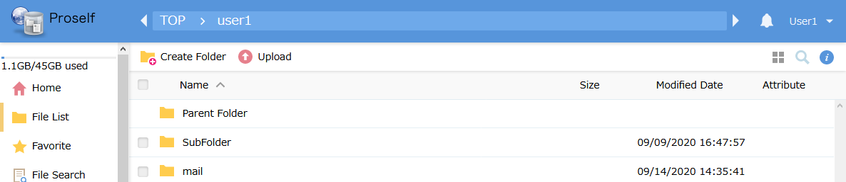
The File List screen

See “4.1.1. Changing the display” for details regarding changing the display, “4.1.2. Searches” regarding searching, and “4.1.3. Detailed information” regarding detailed information display.

The area surrounded by the red box at the top of the screen below shows header columns for the displayed files and folders. Clicking “Name,” “Size,” or “Modified Date” changes the sorting order.
- Note that administrator settings may prevent display of the “Uploaded Date” header column. Clicking “Uploaded Date” changes the sorting order.
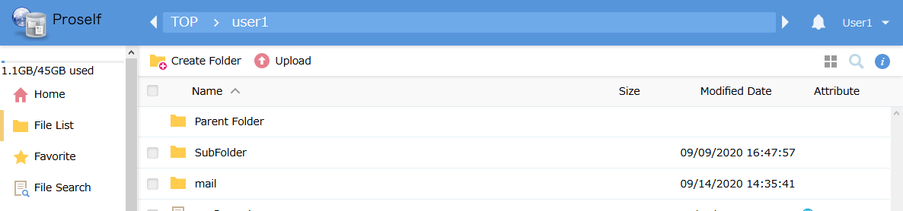
The File List screen

Right-clicking a file or folder shows a menu of operations that can be performed on that file or folder.
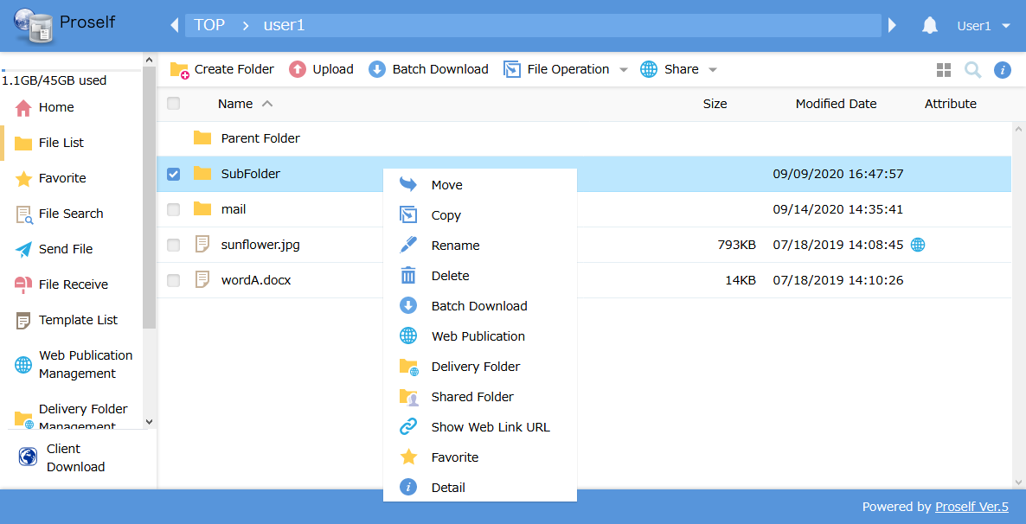
The right-click menu

Note that administrator settings may change the appearance of the file list.
If “Create Folder,” “Upload,” etc., are not displayed in the upper menu, the user is set to read-only, or read-only for the group. In that case, files and folders can only be downloaded.
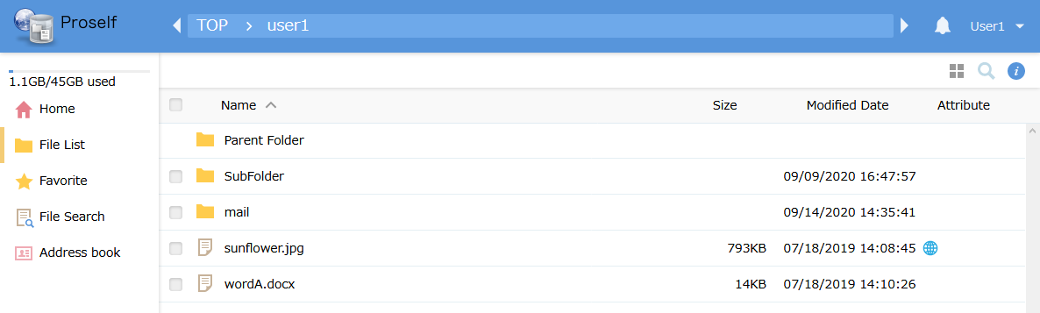
The File List screen (downloads only)

In the case of a fixed thumbnail display like that shown below, or if file names are grayed out when showing detailed information, the user is set to read-only, or group participation is set to preview-only. In that case, files and folders cannot be downloaded; only preview displays in the browser are possible when thumbnails are displayed.
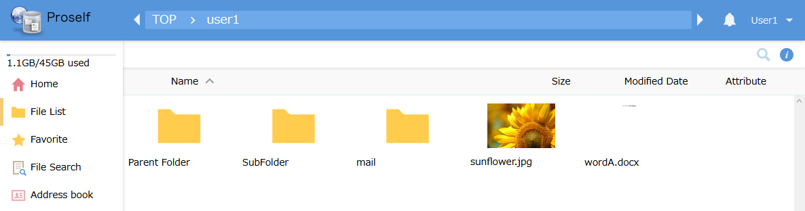
The File List screen (fixed thumbnail display)

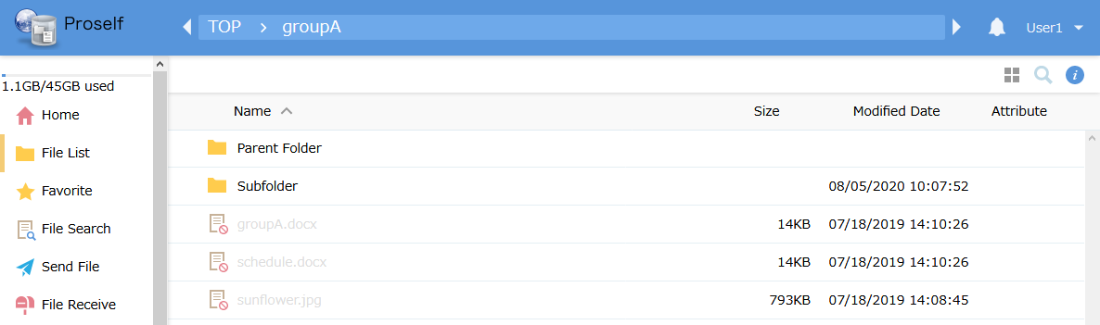
The File List screen
(grayed out during detailed information display)

Changing the display
Clicking the tile icon at the upper right of the File List screen changes the File List screen to the thumbnail view.
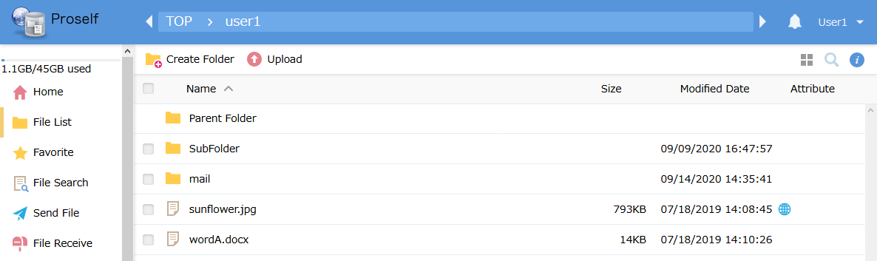
The File List screen (Details View screen)

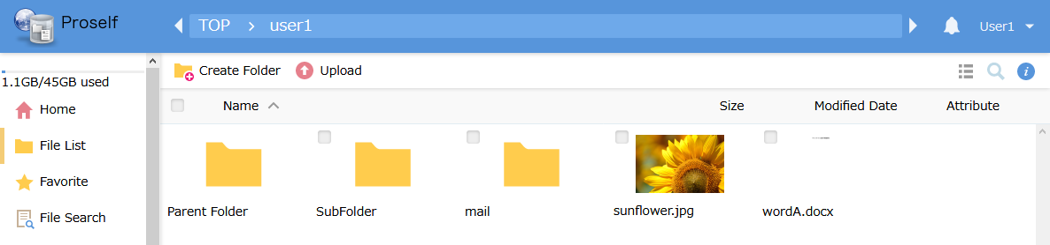
The File List screen (Thumbnail View screen)

Clicking the list icon at the upper right of the Thumbnail View screen changes the File List screen to the Details View screen.
Moving the mouse over one of the file or folder thumbnails shows a popup displaying information for that file or folder.
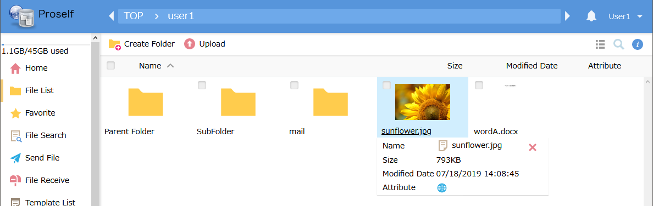
The File List screen (Thumbnail View screen)

Right-clicking the thumbnail for a file or folder displays a menu showing operations that can be performed on that file or folder.
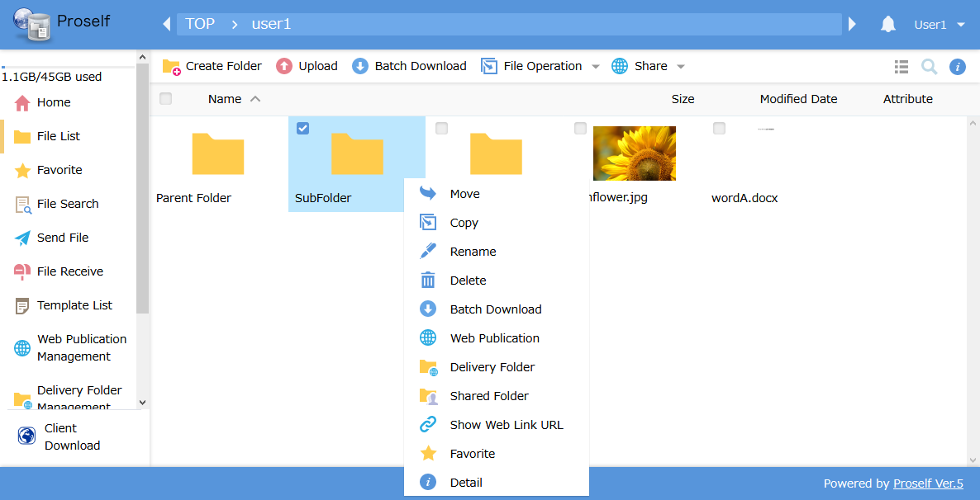
The File List screen (Thumbnail View screen)

You can view a preview like that shown below for an uploaded image, video, PDF file, or Office file by clicking on its thumbnail.
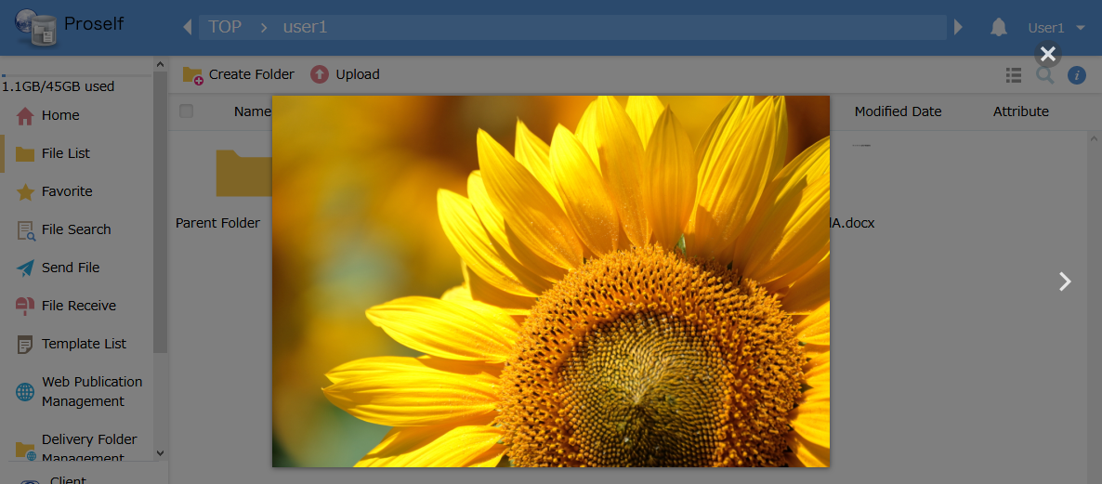
An image preview

See “4.2. Operations” for details regarding the operations that can be performed from this menu.

Search
Clicking the magnifying glass icon at the upper right of the File List screen displays the Search field.
The File List screen

Entering a text string into the search field displays files and folders with names containing that string.
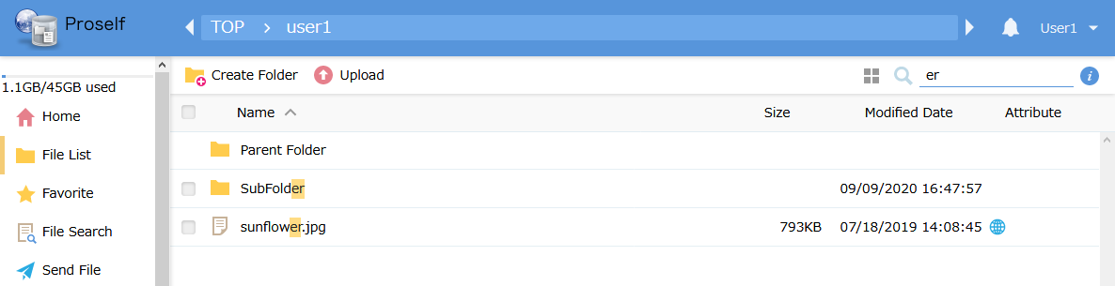
The File List screen (when searching)

Detail
Selecting a file or folder on the File List screen and clicking the “i” (Details) icon at the upper right shows detailed information for the selected file or folder.
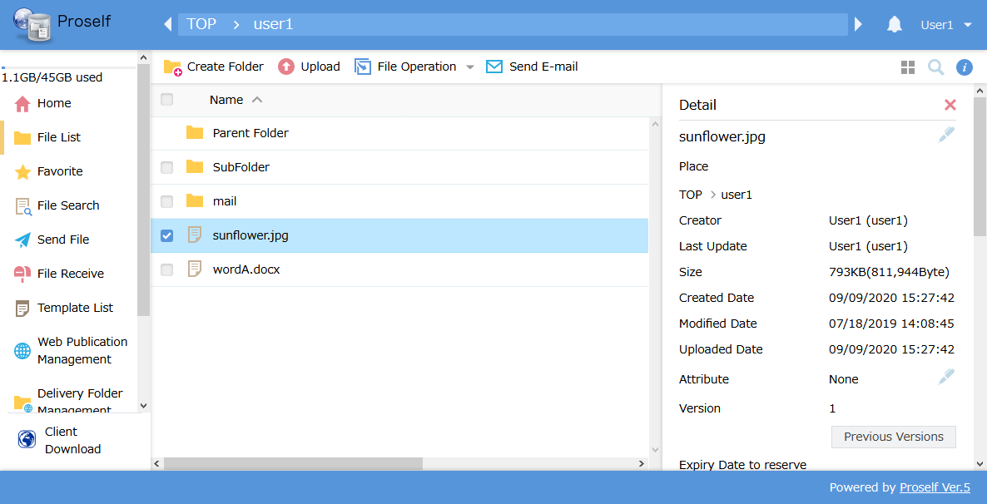
The Details screen

Clicking the pen or other icons on this screen allows performing various operations. See “4.2. Operations” for details.

Operations
The following describes operations that can be performed on the File List and Detail screens.

Create Folder
Click “Create Folder” at the top of the File List screen.
The File List screen

The Create Folder dialog is displayed. Enter an appropriate name, then click the “Make” button.
- Note that the following characters cannot be used in folder names:
\ / : * ? " < > |
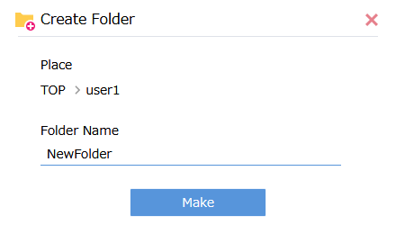
The Create Folder dialog

After creation, the folder is displayed on the File List screen.
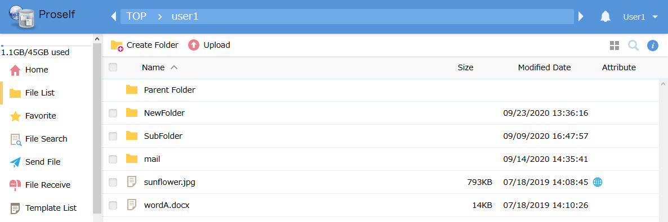
The File List screen

Copy
You can copy files and folders to other locations. There are two ways to do this:
- Click the checkbox next to the file or folder, then click “Copy” in the “File Operation” menu at the top of the screen.
- Right-click the file or folder, then click “Copy” in the menu that appears.

The following shows the example of clicking “Copy” from the “File Operation” menu.
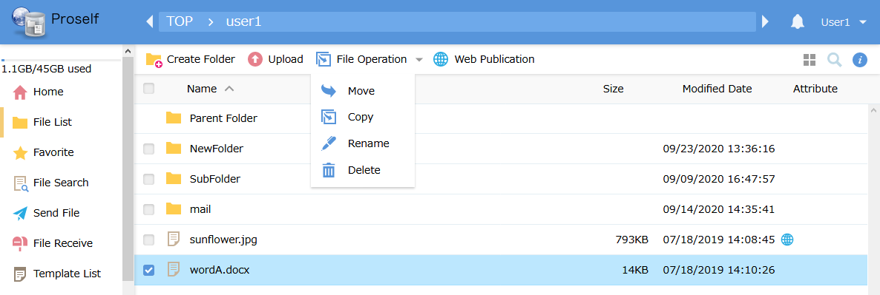
The File List screen

Click the folder name in the Copy Destination Specification screen, then click “Copy.”
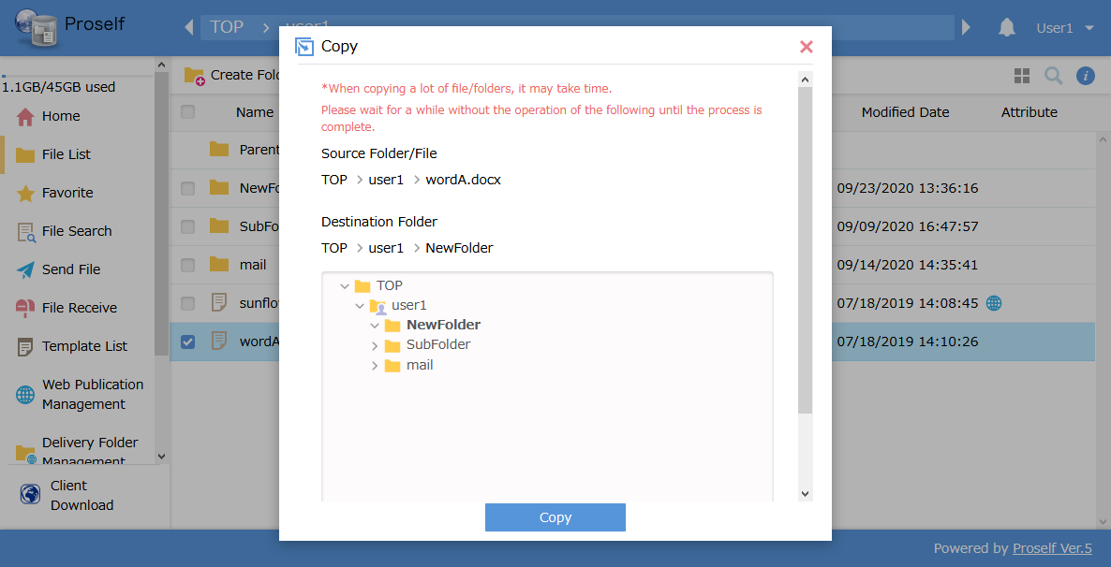
The Copy Destination Specification screen

The file is copied to the folder designated as the copy destination.
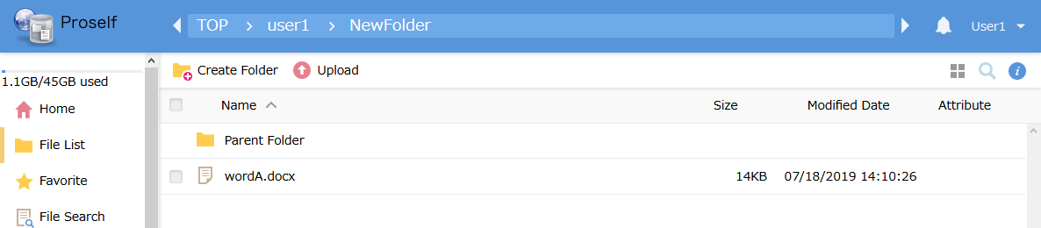
The File List screen

Move
You can move files or folders to other locations. There are two ways to do this:
- Click the checkbox next to the file or folder, then click “Move” in the “File Operation” menu at the top of the screen.
- Right-click the file or folder, then click “Move” in the menu that appears.

The following shows the example of clicking “Move” from the “File Operation” menu.
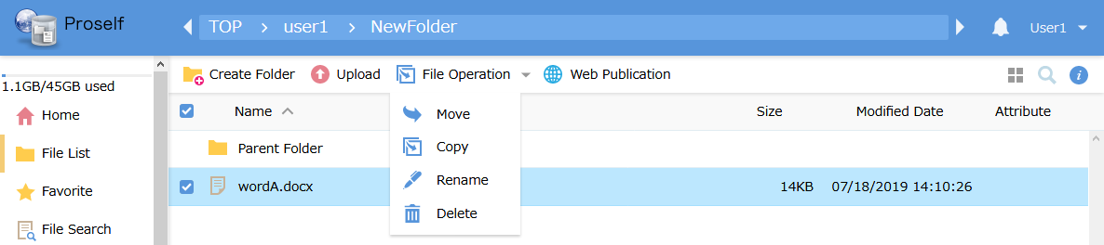
The File List screen

Click the folder name in the Move Destination Specification screen, then click “Move.”
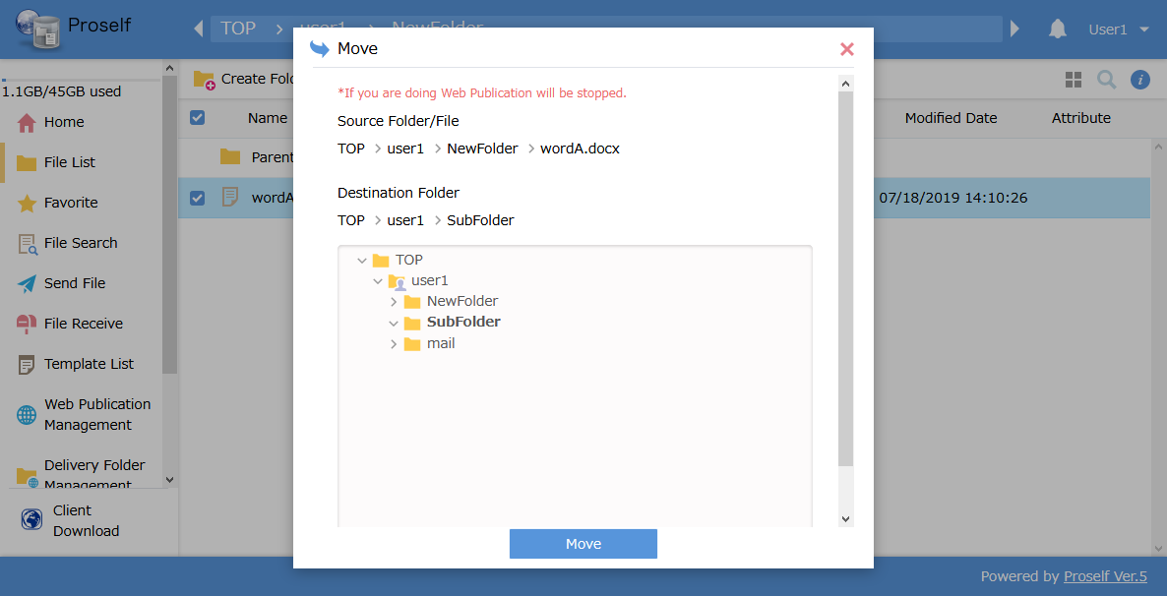
The Move Destination Specification screen

The file is moved to the folder designated as the move destination.
Note: The file is deleted from its original location.
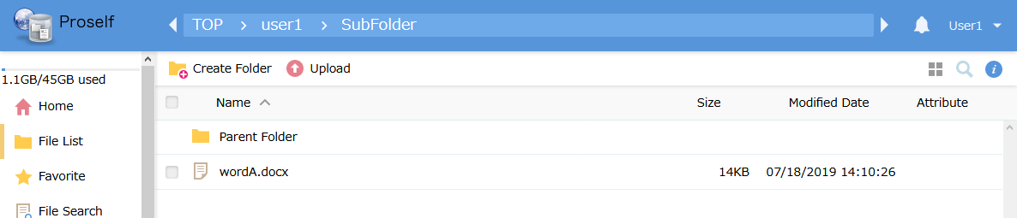
The File List screen

Delete
Deleting files and folders, there are two ways to do this:
- Click the checkbox next to the file or folder, then click “Delete” in the “File Operation” menu at the top of the screen.
- Right-click the file or folder, then click “Delete” in the menu that appears.

The following shows the example of clicking “Delete” from the “File Operation” menu.
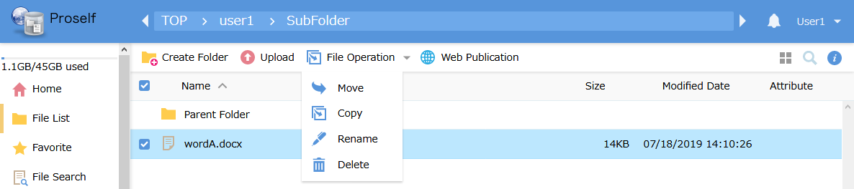
The File List screen

The Deletion Confirmation dialog is shown. If you’re sure you want to delete the file, click the “Delete” button.
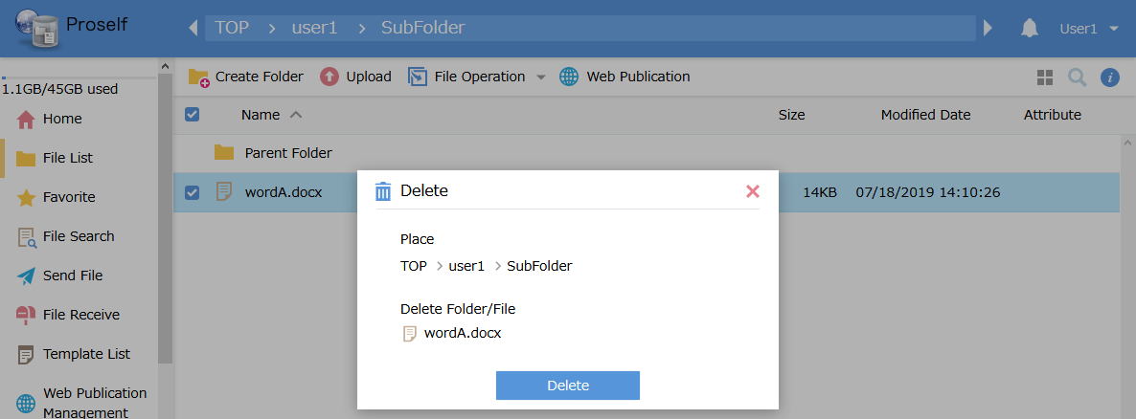
The Deletion Confirmation dialog

The designated file is deleted.
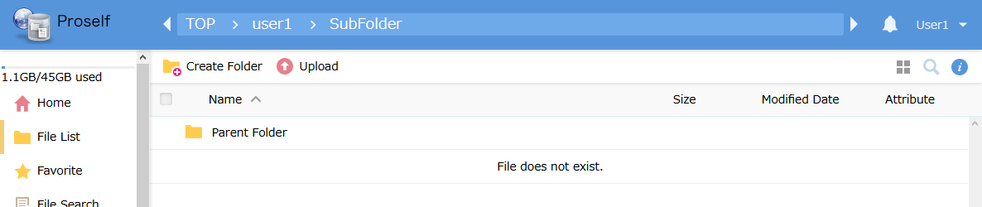
The File List screen

Rename
You can change file and folder names on the File List screen or the Details screen.

Renaming files on the File List screen
There are two ways to do this:
- Click the checkbox next to the file or folder, then click “Rename” in the “File Operation” menu at the top of the screen.
- Right-click the file or folder, then click “Rename” in the menu that appears.

The following shows the example of clicking “Rename” from the “File Operation” menu.
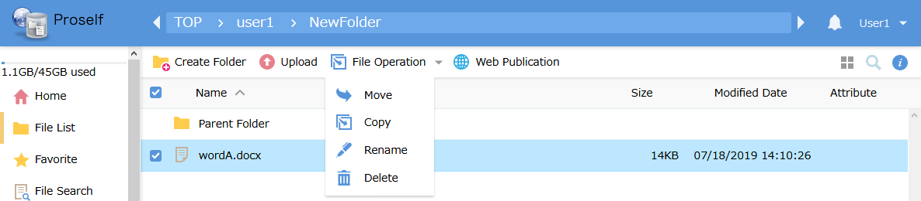
The File List screen

The Rename dialog is displayed. Change the file name, then click the “Rename” button.
- Note that the following characters cannot be used in file or folder names:
\ / : * ? " < > |
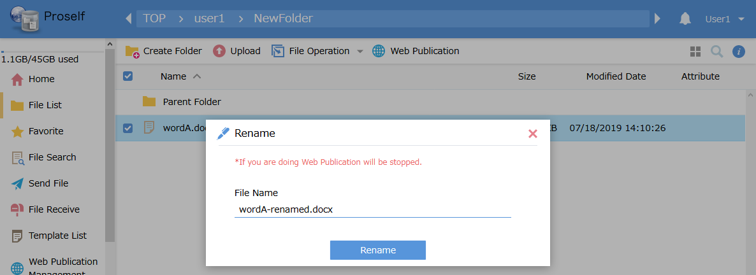
The Rename dialog

The file is renamed.
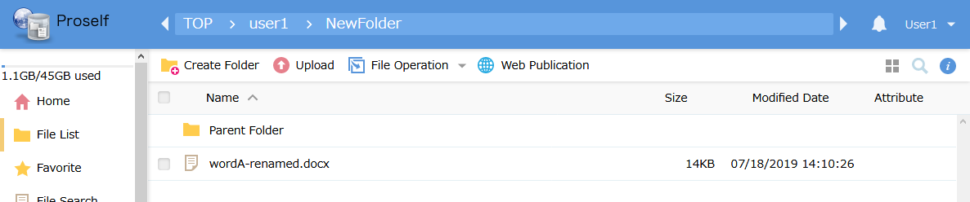
The File List screen

Renaming from the Details screen
Clicking the pen icon next to a file or folder shows a dialog. Change the name as appropriate, then click the “Rename” button.
- Note that the following characters cannot be used in file or folder names:
\ / : * ? " < > |
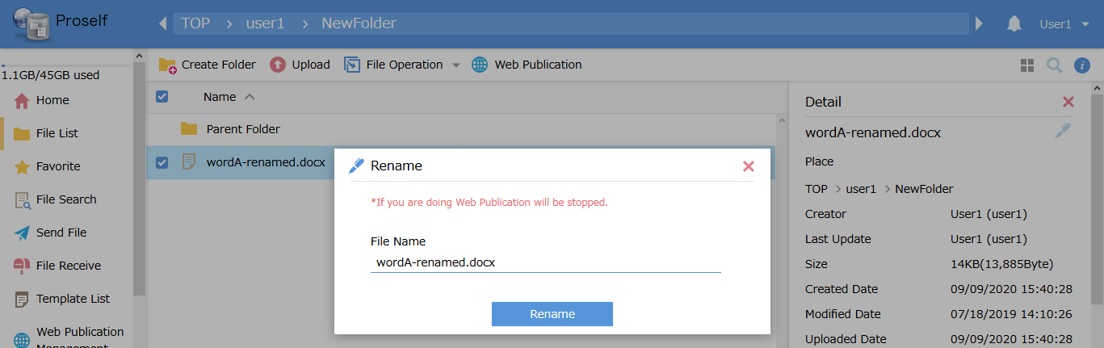
The Rename dialog

Change Attribute
Clicking the pen icon next to “Attribute” in the Details screen shows a dialog. Make changes as appropriate and click the “Update” button.
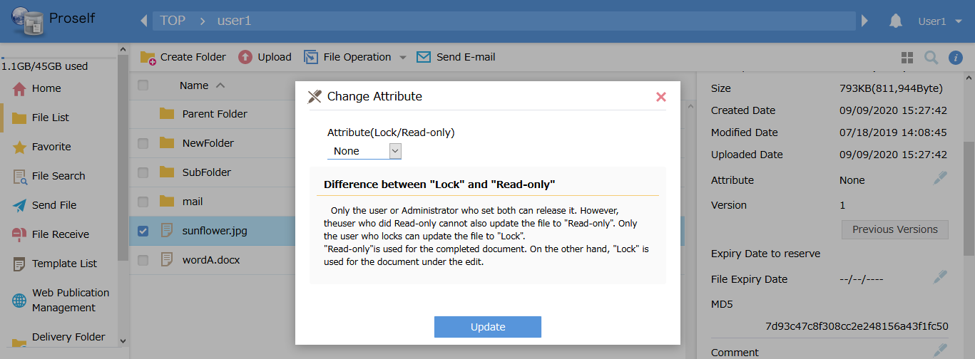
The Change Attribute dialog

The following describes each setting.
Setting name | Description
None | Removes attribute settings.  Note: Only the user who set the attribute and administrators can remove attributes.
Read-only (*) | This prevents file updates, including by the user who set this attribute.
Lock | When sharing a file with others, only the user who set this attribute can update the file.
- This attribute can only be selected by users assigned “Read-only” rights by an administrator.

Set File Expiry Date / Set Folder Expiry Date
Allows setting an expiry date for a file or folder stored in Proself.
When the specified expiry date is reached, the file or folder is automatically deleted.

Clicking the pen icon next to File Expiry Date or Folder Expiry Date shows a dialog. Make changes as appropriate, then click the “Set” button.
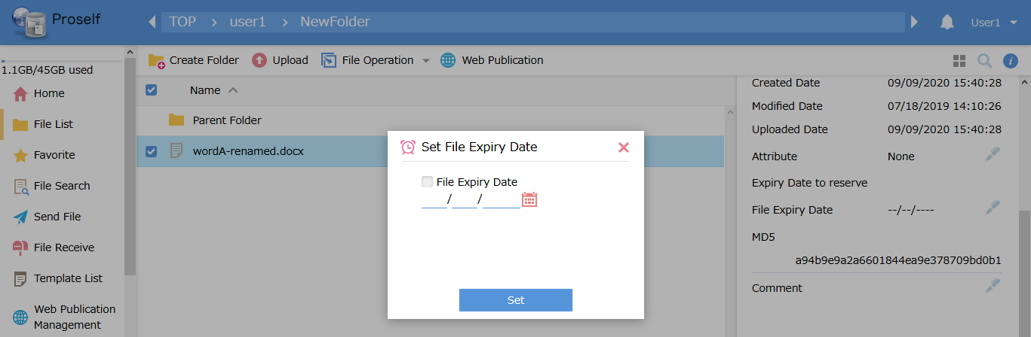
The Set File/Folder Expiry Date dialog

The following describes each setting.
Setting name | Description
File Expiry Date / Folder Expiry Date | When checked, you can specify a date. Unchecking the box removes the time limit.  Note: Administrator settings can prevent unchecking this box.

If an expiry date is set, the attributes in the File List show an alarm clock icon.
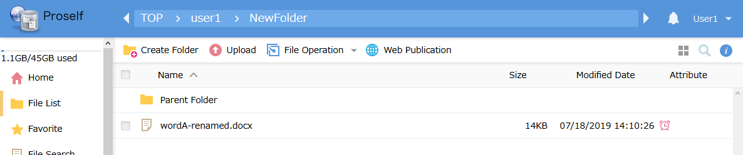
The File List screen

Comment
You can add comments to files and folders.
Clicking the pen icon next to “Comment” shows an editing box. After editing, click the “Set Comment” button.
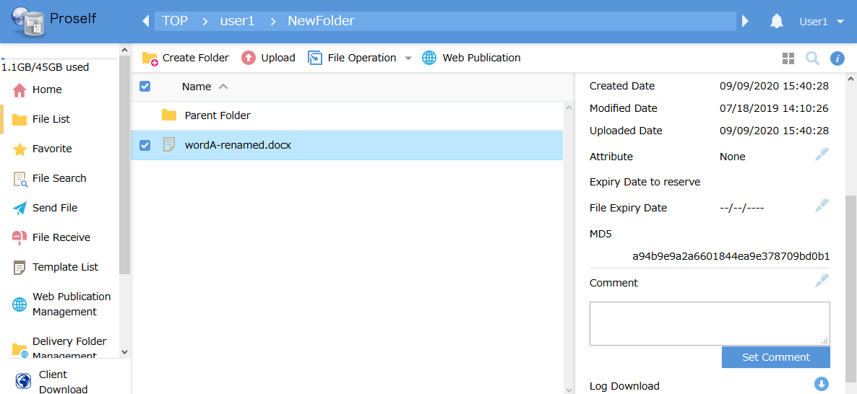
Comment settings

Previous Versions
If a system administrator has enabled Version Control, the specified number of previous file versions are saved.
Clicking “Previous Versions” shows a dialog. Select a version and click the “Download” button.
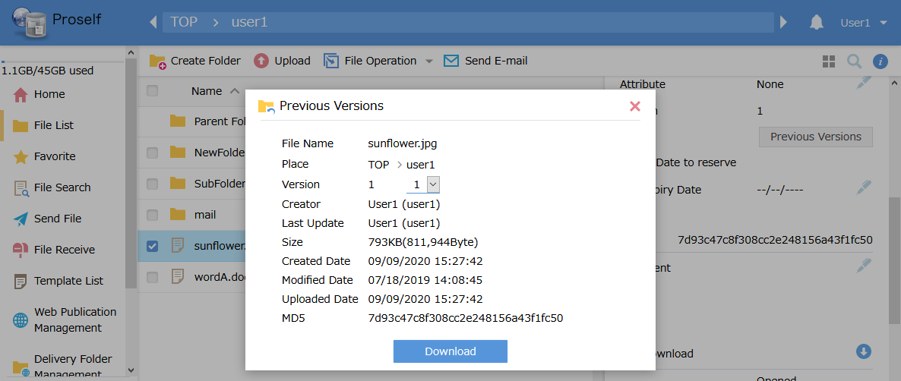
The Previous Versions dialog

For details, see “Proself Ver. 5—Usage Tutorial: Version Control Settings, User Edition” at the following URL: (Japanese Version Only)
https://www.proself.jp/manualtutorial/list/

Log Download
You can download operation logs for files and folders.
Clicking the arrow icon next to “Log Download” shows a dialog. Select the month and year from the pulldown menu for the log type you wish to download and click the “Download” button.
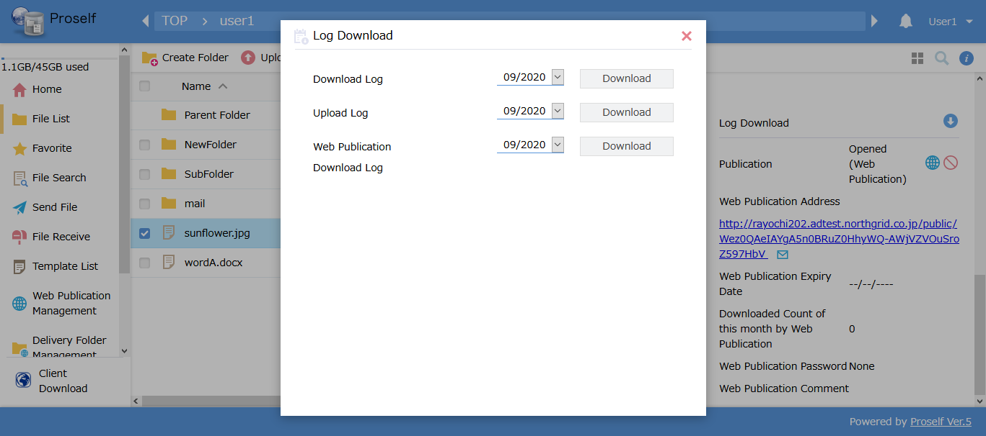
The Log Download dialog

Web Publication
Web Publication settings can be performed from the File List screen or the Details screen.

Web Publication settings on the File List screen
For details, see “3.1. Web Publication.”

Web Publication settings on the Details screen
Click the blue icon next to “Publication.”
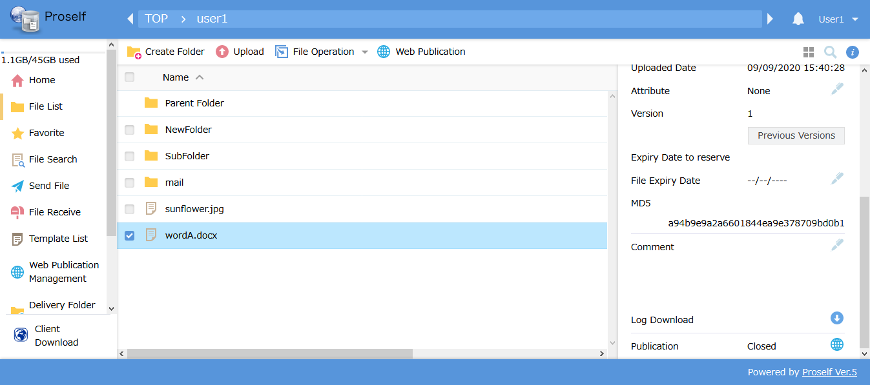
The Detail screen: Set Web Publication

You can click the red icon next to “Publication” to stop a published Web Publication.
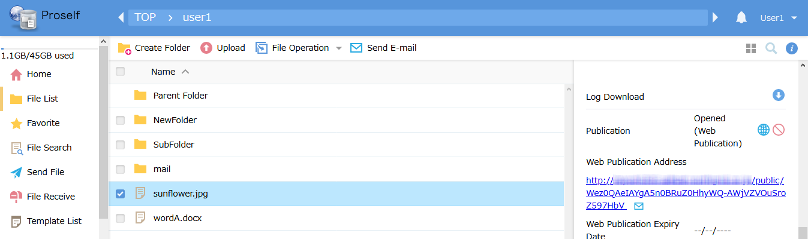
The Details screen: Stop Web Publication

Functions here are the same as those when using the Web Publication function from the File List screen.
For details, see “3.1. Web Publication.”

Delivery Folder
Delivery Folder settings can be performed from the File List screen or the Details screen.

Delivery Folder settings on the File List screen
For details, see “3.2. Delivery Folder.”

Delivery Folder settings on the Details screen
If administrator settings allow use of Delivery Folders, click the yellow icon next to “Publication.”
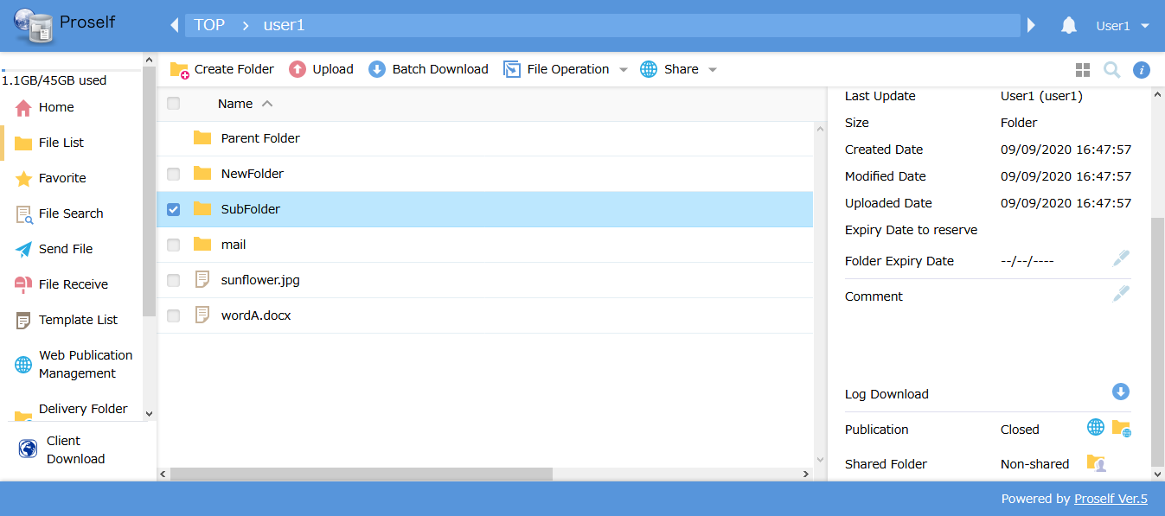
The Details screen: Set Delivery Folder

You can click the red icon next to “Publication” to stop a published Delivery Folder.
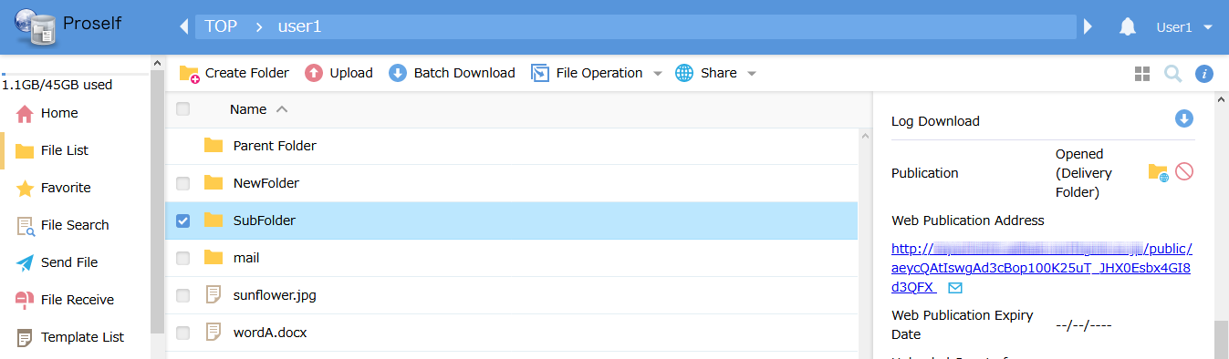
The Details screen: Stop Delivery Folder

Functions here are the same as those when using the Delivery Folder function from the File List screen.
For details, see “3.2. Delivery Folder.”

Send E-mail
When sending published URLs created from Web Publication or Delivery Folder settings, you can follow the procedure below to send e-mails.

There are two ways to do this:
- Click the checkbox next to a file or folder for which Web Publication is active, or next to a folder designated as a Delivery Folder, then click “Send E-mail” at the top of the screen.
- Right-click a file or folder for which Web Publication is active, or a folder designated as a Delivery Folder, then click “Send E-mail” in the menu that appears.

The following shows the example of clicking “Send E-mail” at the top of the screen.
- Note that “Send E-mail” will not be displayed if the administrator has not performed mail server settings, or if the user does not have “Send E-mail” rights.
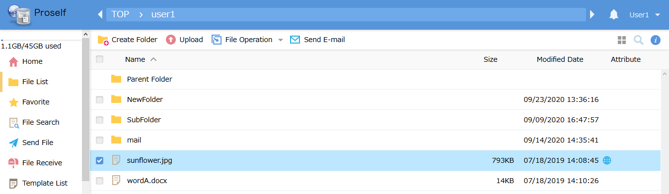
The File List screen

The Send E-mail dialog is shown. Enter the destination address, then click the “Send” button.
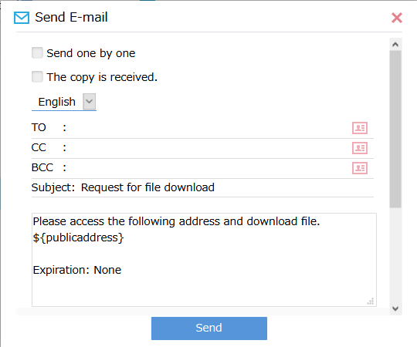
The Send E-mail dialog

- Clicking “Send” will sometimes result in a “Mail address was not selected in User setting” error. This occurs when the user has not set an e-mail address. See “4.4.2. User Settings” regarding how to set an e-mail address.

The following describes each setting.
Setting name | Description
Send one by one | When checked, emails will be individually sent to each address specified in the “TO” field.
The copy is received. | When checked, a copy of the email will be sent to your e-mail address.
TO/CC/BCC | Input e-mail addresses in the TO, CC, and BCC fields.
Subject | A different subject line can be input here. (A subject line specified by the system administrator is input by default.)
Body | Enter a body message. (A body message specified by the system administrator is input by default.)  - If a default body message is displayed, be careful not to delete the “${publicaddress}” tag; doing so will prevent the download URL from being included in the received e-mail.

Show Web Link URL
Right-click the file or folder and click “Show Web Link URL” in the menu that appears.
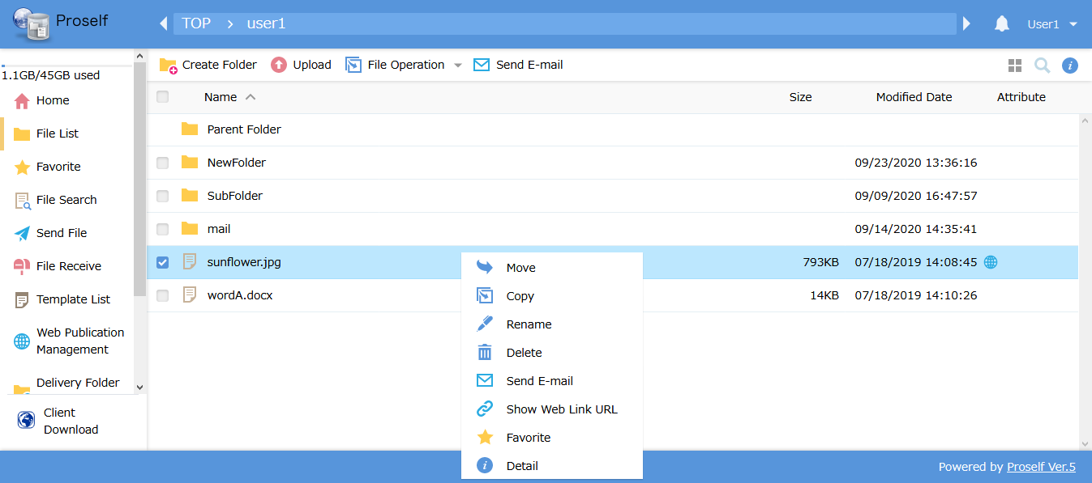
The File List screen

A URL for directly accessing the selected file or folder is displayed.

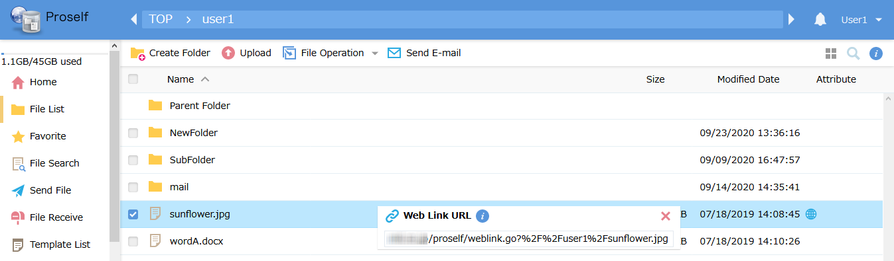
A Web Link URL

Information
Clicking the bell icon to the left of the user name at the upper right shows the Information List screen.
- If a number is displayed next to the icon, it indicates the number of unread messages.
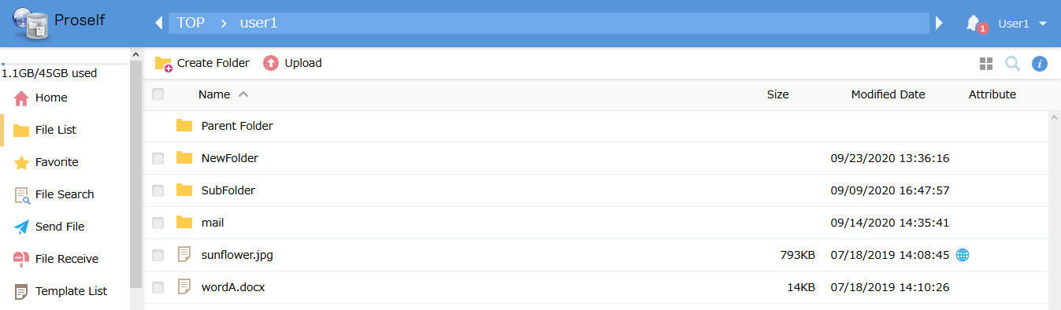
The File List screen

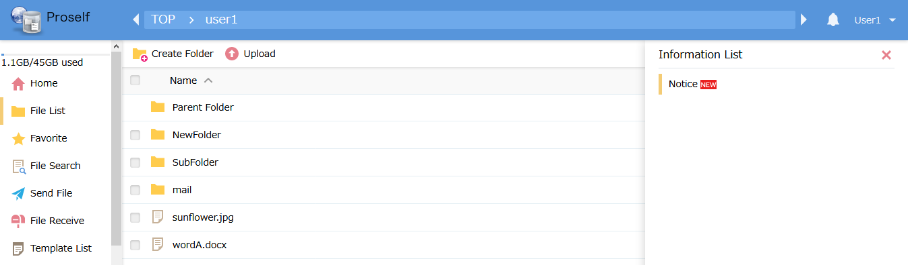
The Information List screen

User Menu
Clicking the triangle to the right of the user name at the upper right shows the User Menu screen, where you can perform various settings.
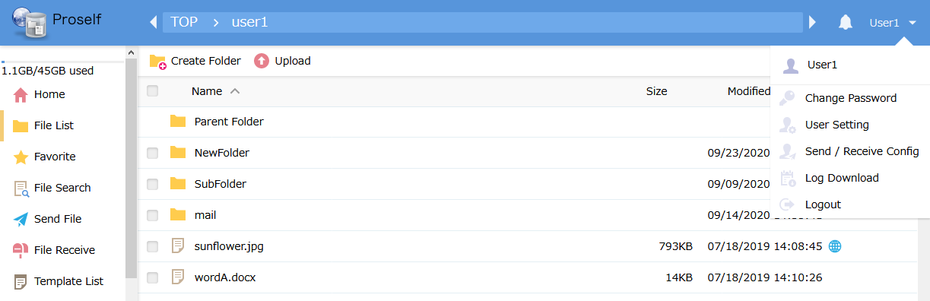
The File List screen

See the next section for descriptions of each setting.

Change Password
Changes the password for the logged-in user.
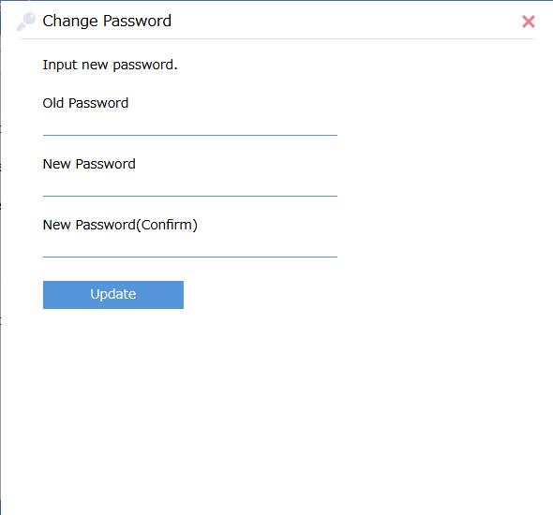
The Change Password dialog

Characters that can be used in passwords are shown below.
- Note that system administrators can set password lengths, expiry dates, etc.
Character type | Description
Capital letters | A, B, C, … Z
Lower-case letters | a, b, c, … z
Numerals | 0, 1, 2, … 9
Special characters | ! # $ % ( ) = + * ? _ { } ; : [ ]  Note: The following characters cannot be used: < > ’ ” &

After performing settings, click the “Update” button to change the password.

User Setting
Allows you to perform settings specific to the logged-in user.
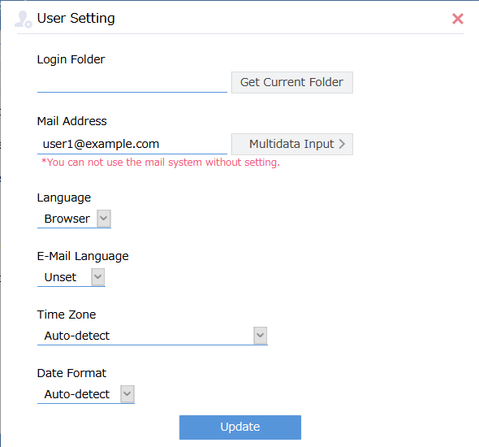
The User Settings screen

The following describes each setting.
Setting name | Description
Login Folder | Allows changing folder positions displayed when the user first logs in to Proself.
Mail Address | Sets the user’s e-mail address.  Note: This setting must be performed to use the “Send E-mail” function.
Language | Sets the language used for page display. Select one of “Browser,” “Japanese,” “English,” or “Chinese.”
E-Mail Language | Sets the language used for e-mail notifications sent to the user’s e-mail address. Select one of “Japanese,” “English,” or “Chinese.”  Note: If the system administrator has not prepared English and Chinese notification e-mails, those emails will be sent in Japanese, even if English or Chinese is selected here.
Time Zone | Sets the user’s time zone. File creation, modification, and upload dates, etc., are displayed using the specified time zone.
Date Format | Sets the date format to be used. Select from among “Auto-detect,” “yyyy/MM/DD,” “MM/DD/yyyy,” or “DD/MM/yyyy.”

After performing settings, click the “Update” button on the screen to save them.

Log Download
Allows downloading a log of all operations performed by the logged-in user. Select the month and year from the pulldown menu and click the “Download” button. A download of the log for the selected log type will begin.
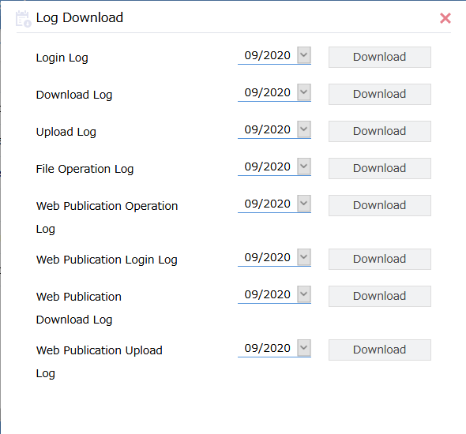
The Log Download screen

Favorite
Allows designating “favorite” files or folders that are frequently used. Using this function allows quick access to those files and folders.
- Favorites can be managed for individual users.

Clicking “Favorite” from the menu on the left shows the Favorite List screen.
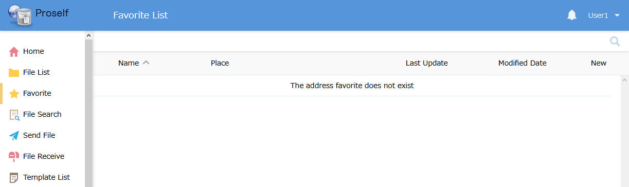
The Favorite List screen

See the next section regarding Favorite operations.

Add Favorite
Right-click a file or folder from the File List screen and select “Favorite” from the menu that appears.
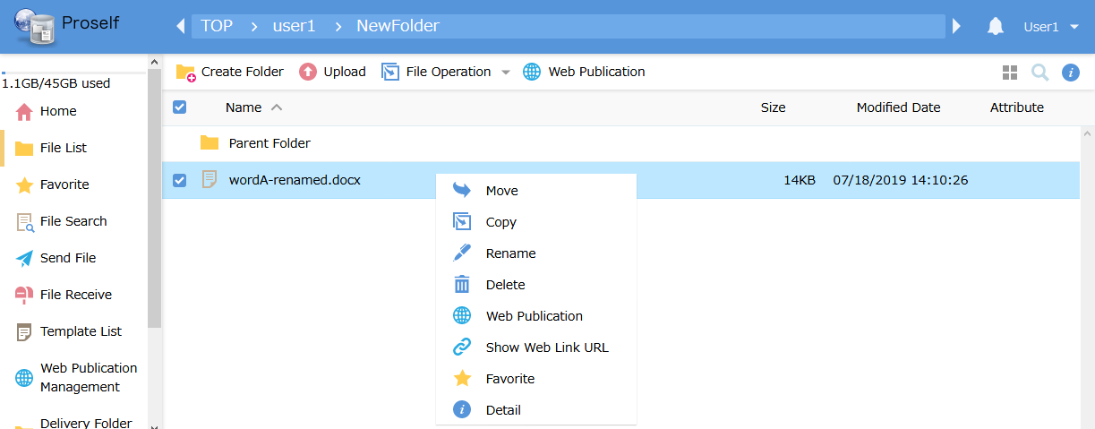
The File List screen

The Add Favorite dialog is displayed. Perform settings as needed.
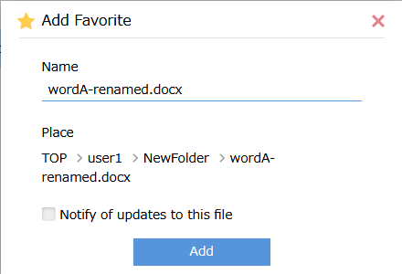
The Add Favorite dialog

The following describes each setting.
Setting name | Description
Name (*1) | The name of the selected file or folder is displayed by default, but this can be changed to something that allows easy management.
Notify of updates to this file (*2) | When the user or another user sharing files or folders with the user makes changes to files or folders marked as favorites, the number of modifications is indicated by a notification number.
Note 1: Required setting
Note 2: For folders, “Notify of updates in this folder” is displayed instead.

After performing settings, click the “Add” button to register a favorite.

After registration is complete, files and folders marked as favorites are displayed under “Favorite” in the menu on the left and on the Favorite List screen.
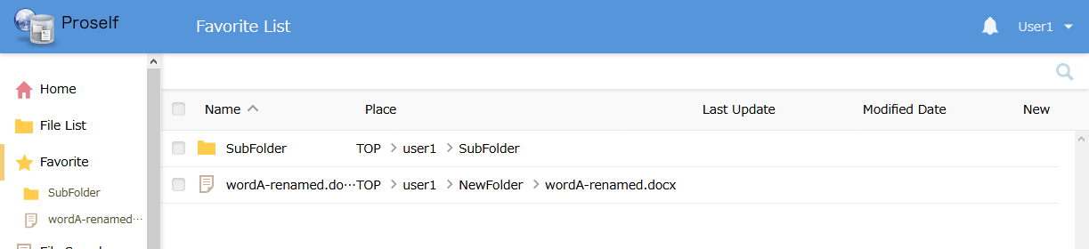
The Favorite List screen

Clicking the name of a favorite in the menu on the left takes the user to the corresponding file or folder. For files, the file name is highlighted. For folders, the screen moves to the folder location.
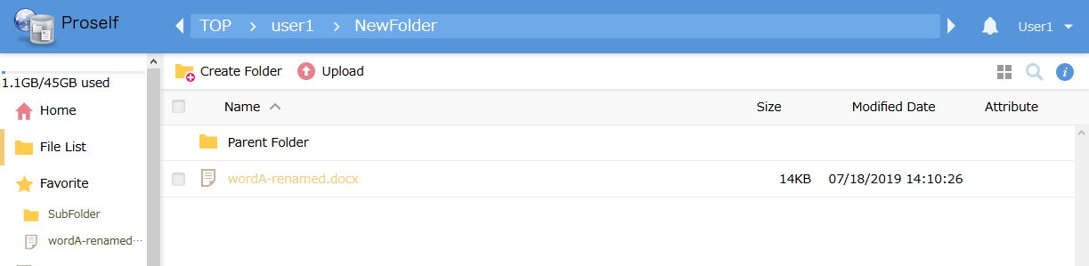
The File List screen (for files)

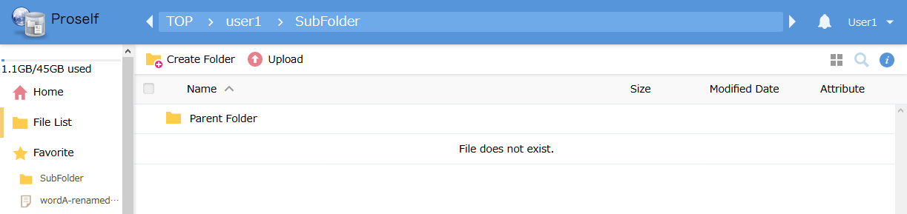
The File List screen (for folders)

When files or folders marked as favorites are deleted, their names will be grayed out in the Favorites list.
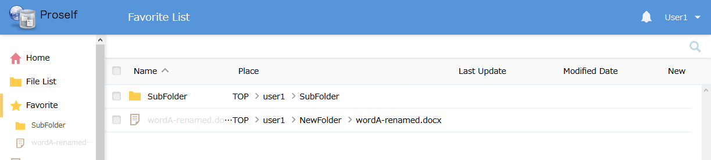
The Favorite List screen

In that case, clicking on the name in the menu on the left will not take the user to the associated file or folder, but rather show the Deletion Confirmation dialog for the invalid favorite. If you wish to delete the favorite, click the “Delete” button.
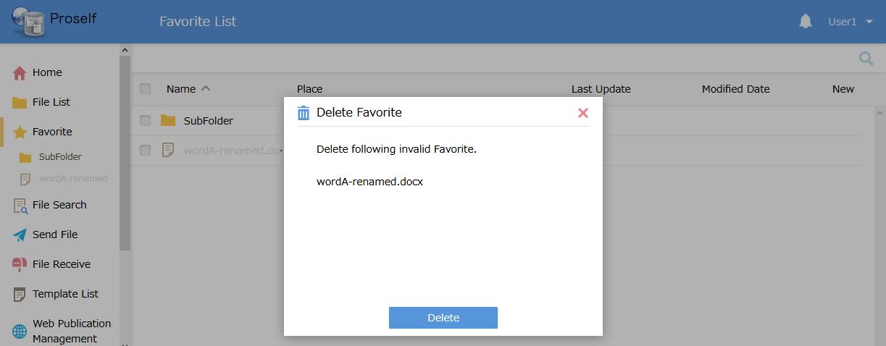
The Deletion Confirmation dialog

Update Favorite
Click the checkbox next to the appropriate entry on the Favorite List screen and click “Update” at the top of the screen.
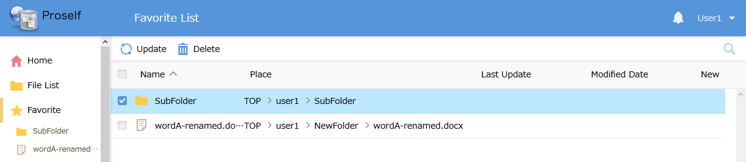
The Favorite List screen

The “Update Favorite” dialog is shown. Perform settings as needed.
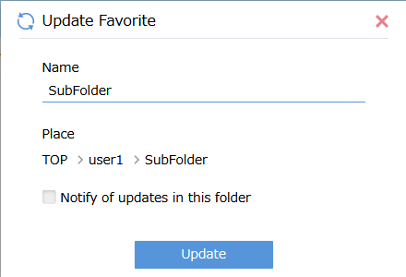
The Update Favorite dialog

Settings here are the same as described in “4.5.1. Add Favorite.”
After performing settings, click the “Update” button to update them.

Delete Favorite
Click the checkbox next to the appropriate entry on the Favorite List screen and click “Delete” at the top of the screen.
The Favorite List screen

The “Delete Favorite” dialog appears. If you want to delete the favorite, click the “Delete” button.
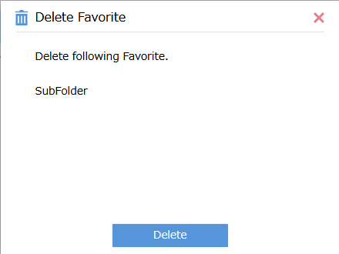
The Delete Favorite dialog

When deletion is complete, you can confirm that the favorite was deleted because it is no longer shown under “Favorite” in the menu to the left or on the Favorite List screen.
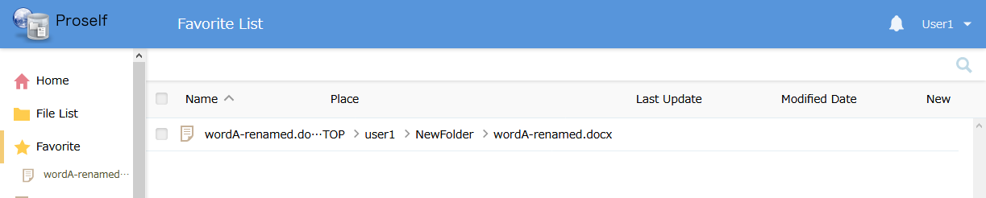
The Favorite List screen

File Search
For details, see “Proself Ver. 5—Usage Tutorial: File Searches” at the following URL: (Japanese Version Only)
https://www.proself.jp/manualtutorial/list/

Template
Allows managing templates for e-mail addresses, subjects, and e-mail body used when sending file send notifications or file request notifications.
Preparing templates for various tasks reduces time required for entering this information, making sending and receiving files more efficient.
Clicking “Template List” in the menu to the left displays the Template List screen.
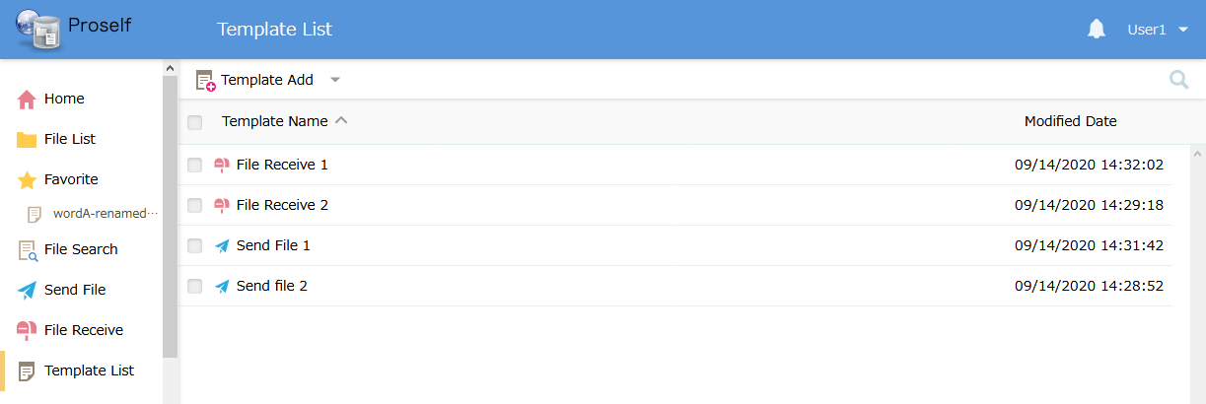
The Template List screen

See the following section for descriptions of template operations.

Add Template
Click “Send File” or “File Receive” in the “Template Add” menu at the top of the Template List screen.
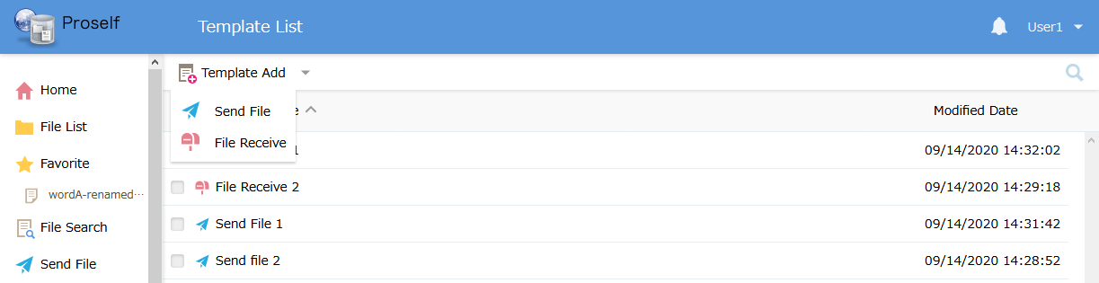
The Template List screen

When clicking “Send File”
The Send File Add Template screen is displayed. Perform settings as needed.
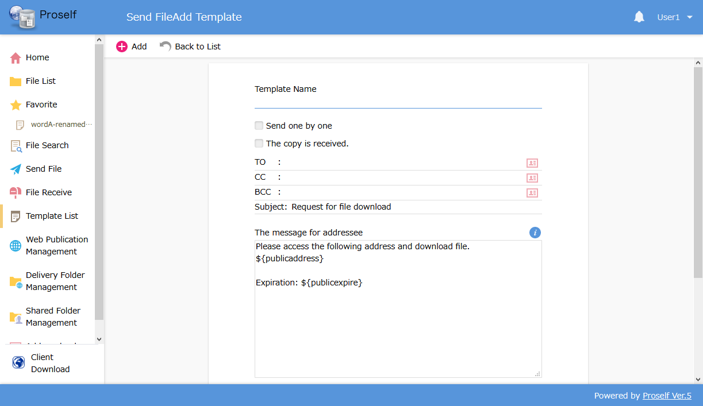
The Send File Add Template screen

The Template Name setting is required. See “3.3. Send File” regarding other settings.

When clicking “File Receive”
The “File Receive Add Template” screen is displayed. Perform settings as needed.
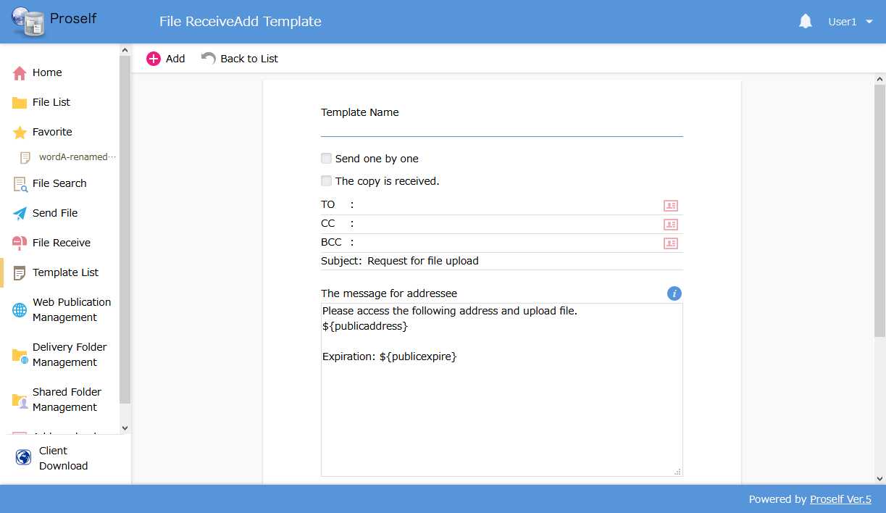
The File Receive Add Template screen

The Template Name setting is required. See “3.4. File Receive” regarding other settings.

After performing settings, click the “Add” button to save the template.

Update Template
Click the checkbox next to the appropriate template on the Template List Screen, then click “Update” under the “Template Operation” menu at the top of the screen.
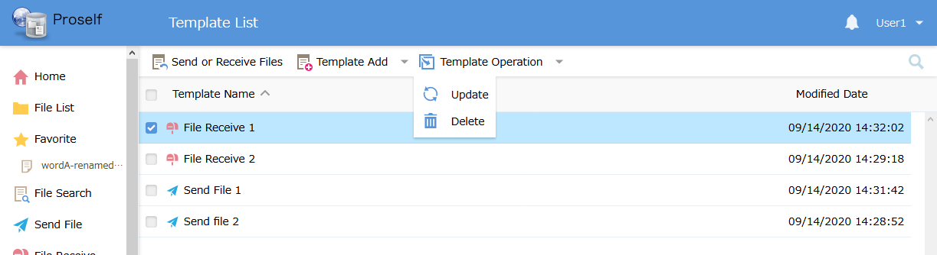
The Template List screen

The “Update Template” screen is displayed. Perform settings as needed.
Note: The screen below shows the case of the File Receive Update Template screen.
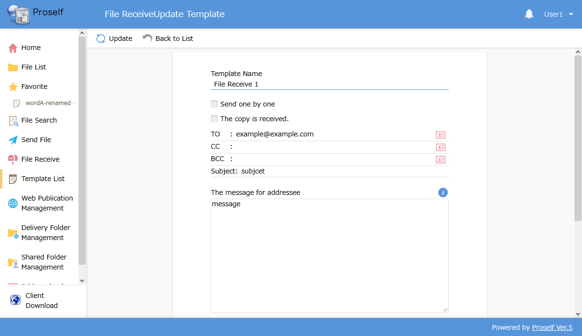
The File Receive Update Template screen

Settings are the same as in “4.7.1. Add Template.”

After performing the settings, click “Update” to update the template.

Delete Template
Click the checkbox next to the appropriate template on the Template List screen, then click “Delete” in the “Template Operation” menu at the top of the screen.
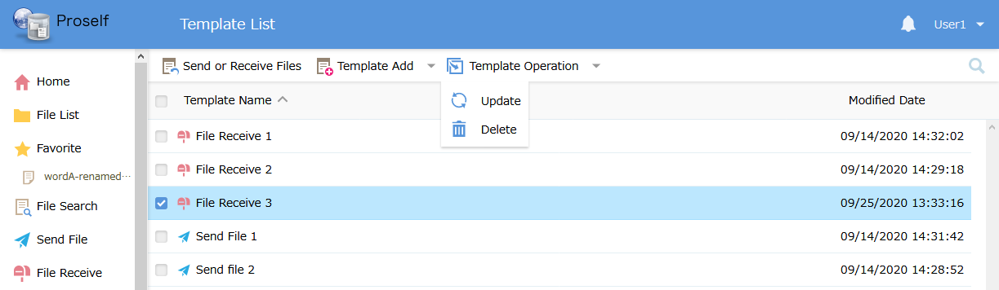
The Template List screen

The Delete Template dialog appears. If you’re sure you want to delete the template, click the “Delete” button.
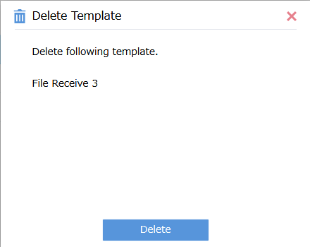
The Delete Template dialog

When deletion is complete, you can confirm that the template is no longer shown on the Template List screen.
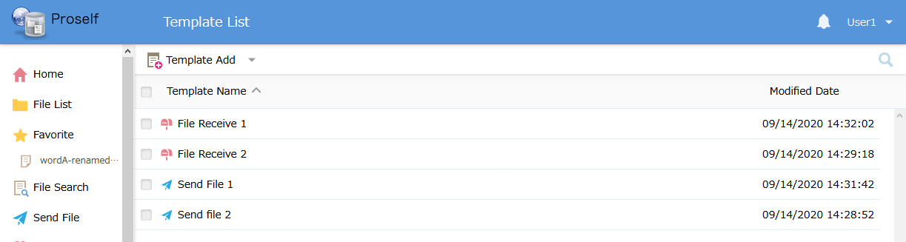
The Template List screen

Send File / File Receive
You can use pre-created templates when using the Send File and File Receive functions.

On the Template List screen, click the checkbox next to the appropriate template name, then click “Send or Receive Files” at the top of the screen.
Note: The following screen shows the case of selecting a Send File template.

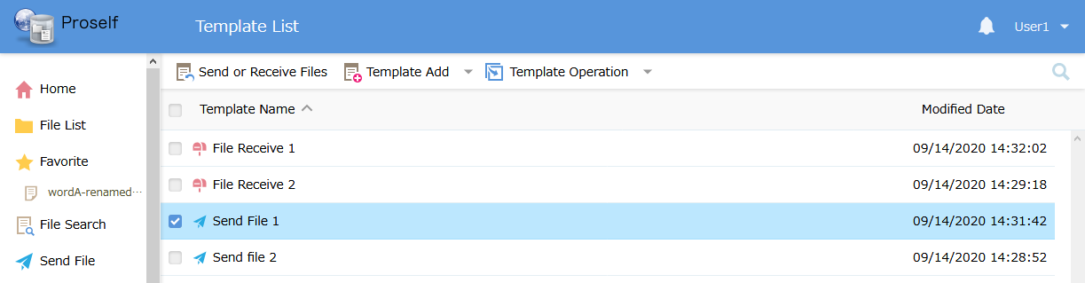
The Template List screen

The Send File or File Receive screen with the template applied to each setting is shown.
Note: The following screen shows the case of selecting a Send File template.
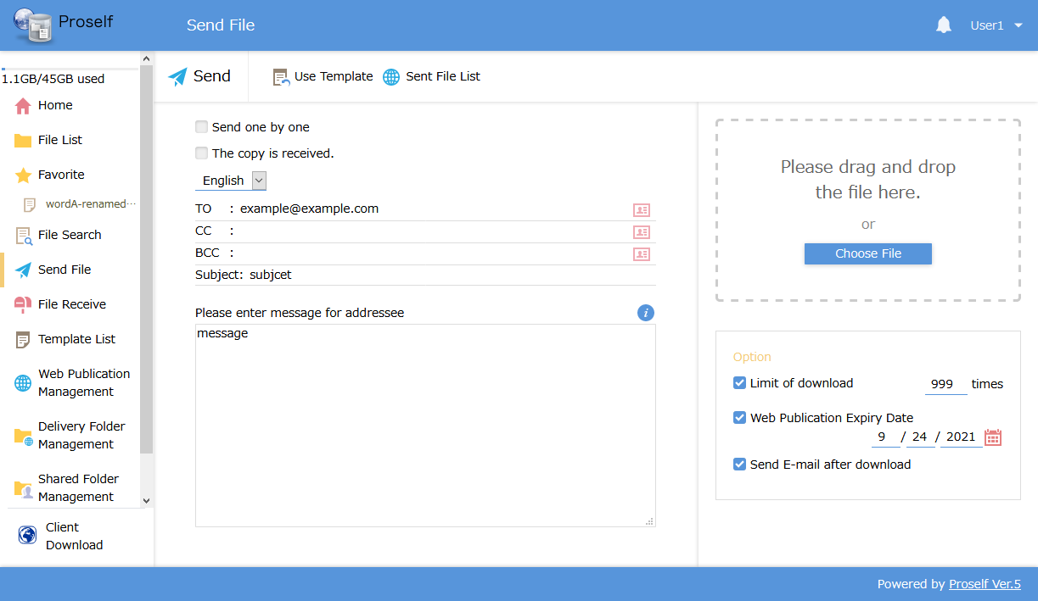
The Send File screen

Update any settings as necessary, then click the “Send” button.

Address book
You can edit an address book for use with the Send File, File Receive, or Send E-mail functions.
Note: Separate address books are maintained for each user.

Click “Address book” at the menu on the left to show the Address List screen.
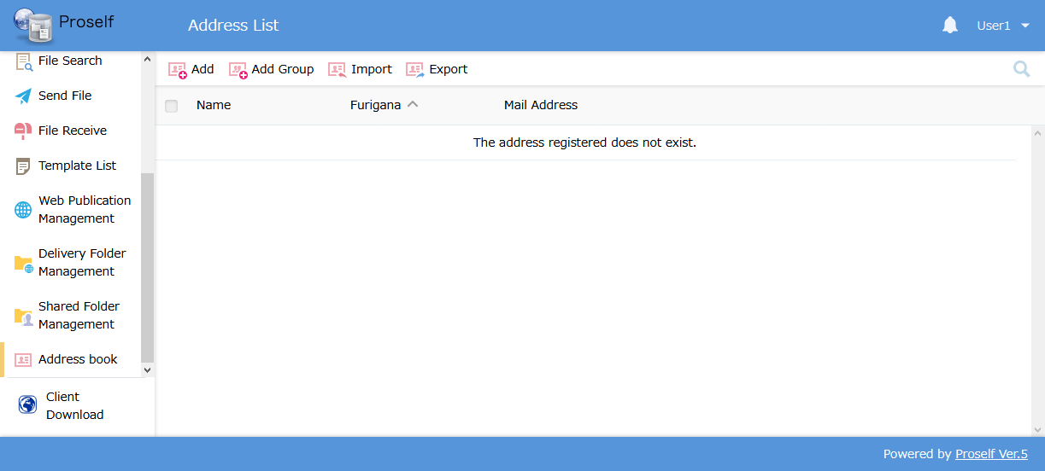
The Address List screen

Add Address / Update Address
Allows you to add or edit an address.

To add an address, click “Add” in the menu at the top of the screen. The Add Address dialog is shown.
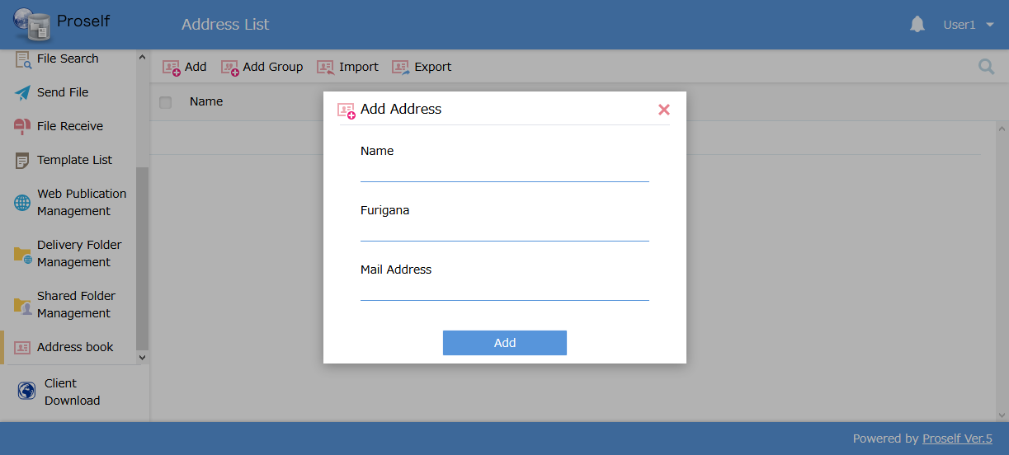
The Add Address dialog

To update an address, click the checkbox next to the appropriate address on the Address List screen, then click “Update” in the “Address Operation” menu at the top of the screen.
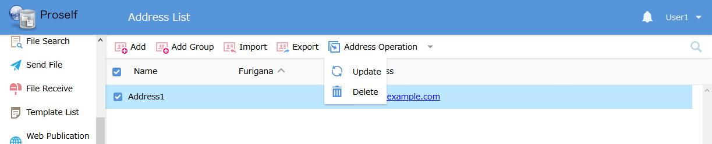
The Address List screen

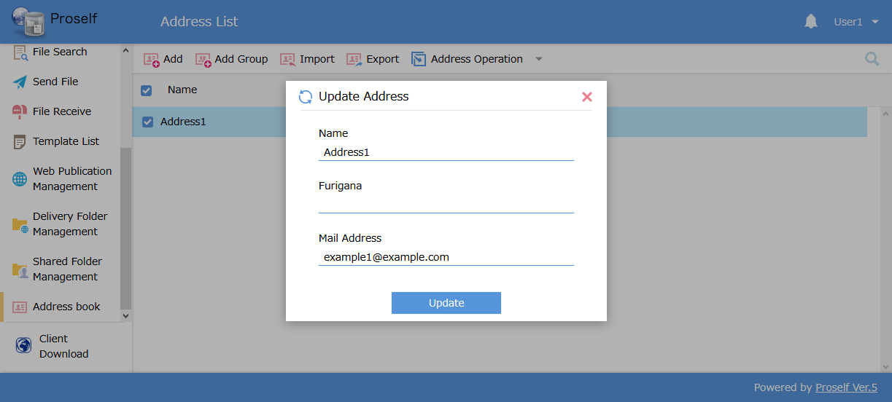
The Update Address dialog

The following describes each setting.
Setting name | Description
Name | The name used as the sender when sending the e-mail.
Furigana | Furigana for the sender’s name. (Used for Japanese names)
Mail Address (*) | The address used when sending the e-mail.
*Required item

After performing settings, click “Add” or “Update” to add or update an address.

Add Group / Update Group
You can add or update groups of e-mail addresses previously added to an address book.

To add a group, click “Add Group” at the top of the screen. The Add Group dialog is shown.
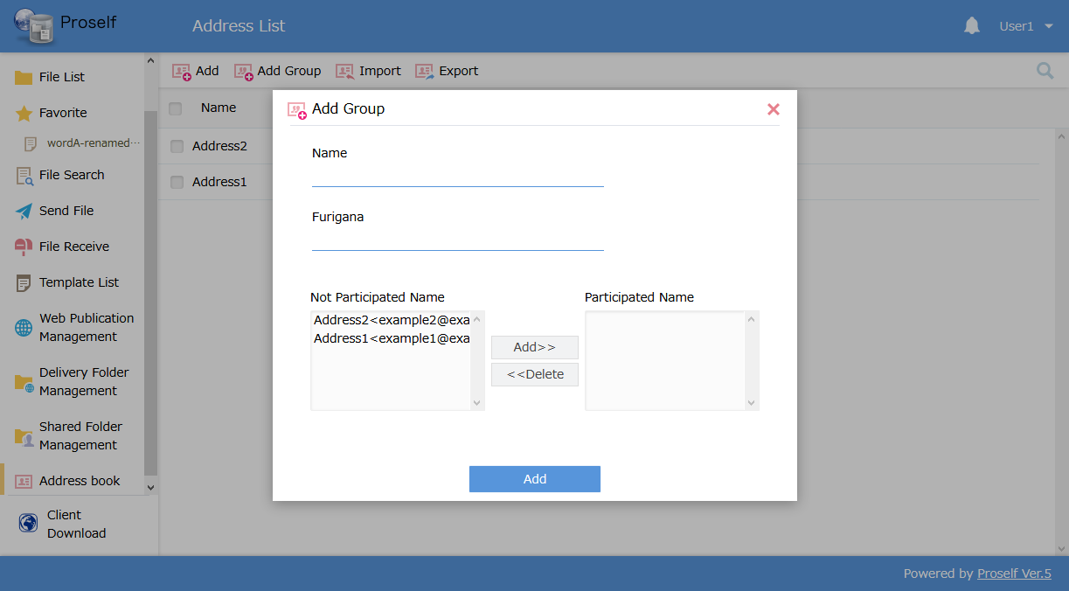
The Add Group dialog

To update a group, click the checkbox for the appropriate group on the Address List screen, then click “Update” in the “Address Operation” menu at the top of the screen.
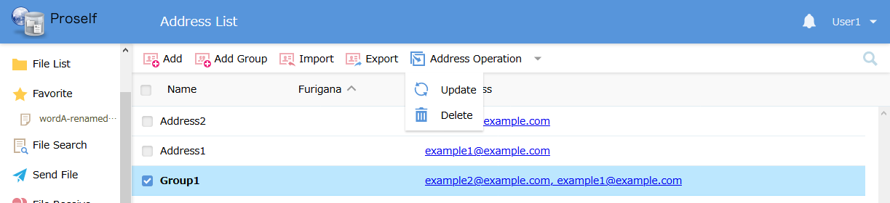
The Address List screen
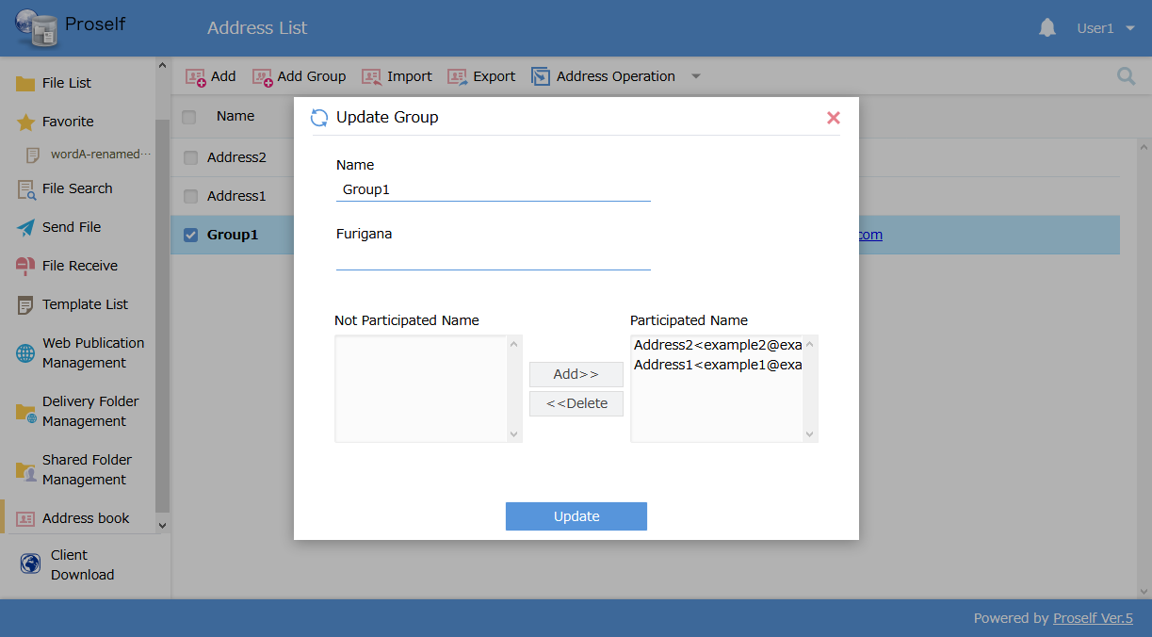
The Update Group dialog

The following describes each setting.
Setting name | Description
Name (*) | The group name.
Furigana | Furigana for the group name. (Used for Japanese names)
Not Participated Name | A list of e-mail addresses not included in the group.
Participated Name | Shows a list of e-mail addresses included in the group.
Add>> | Adds the selected e-mail address to the group.
<<Delete | Removes the selected e-mail address from the group.
*Required item

After performing settings, click “Add” or “Update” to add or update the group.

Delete Address
Deletes a saved e-mail address or group.

Click the checkbox for the appropriate e-mail address or group on the Address List screen, then click “Delete” in the “Address Operation” menu at the top of the screen.
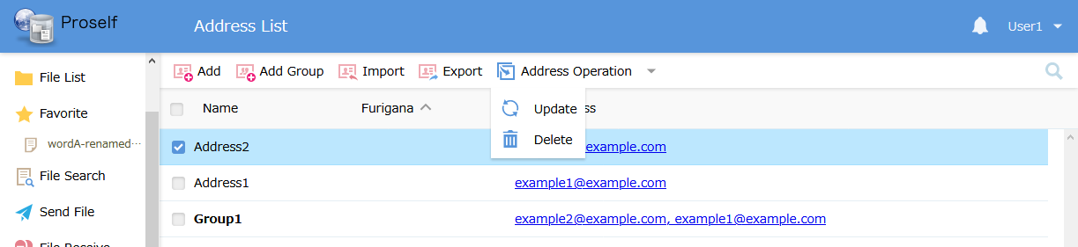
The Address List screen

The Delete Confirmation dialog is displayed as shown below. If you want to delete the e-mail address, click the “Delete” button.
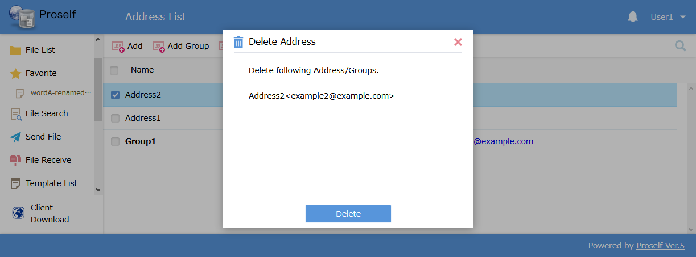
The Deletion Confirmation dialog

Deletes an e-mail address from the Address List screen.
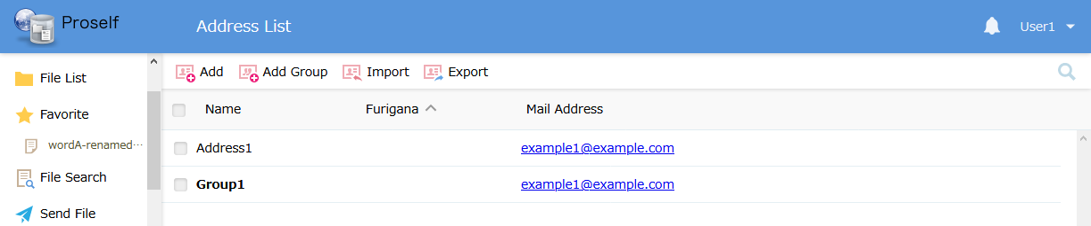
The Address List screen

Import
Click “Import” at the top of the screen.
The Address List screen

The Import Address screen is shown. Click “Select files” to select a .CSV file to import.
See the on-screen description regarding the format for imported .CSV files.
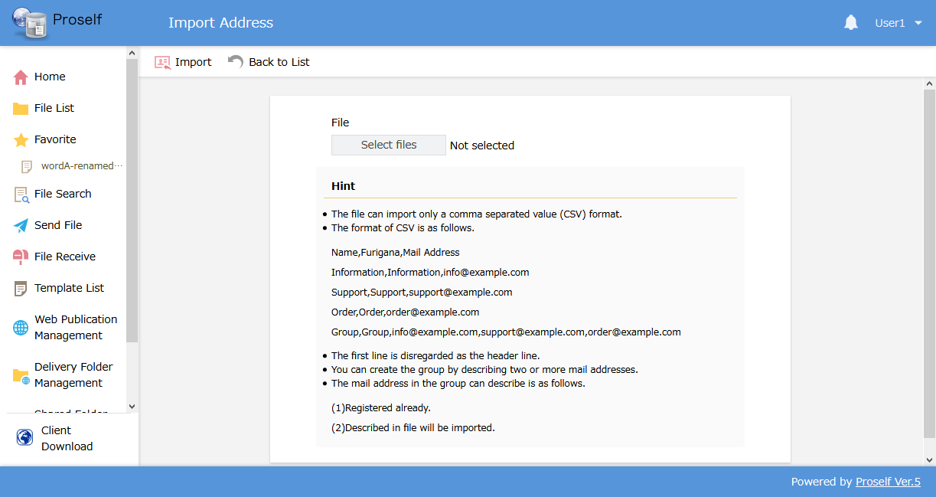
The Import Address screen

Clicking “Import” at the upper left on the screen shows the Import Address dialog. Confirm the number of users to be imported, then click the “Import” button.
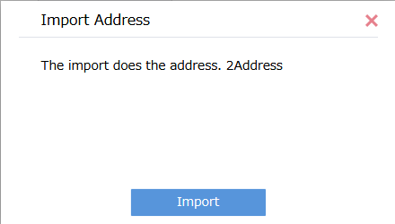
The Import Address dialog

A dialog is shown when the import is complete. Click the “OK” button.
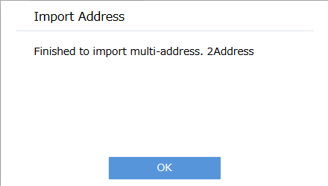
The Import Address dialog

The Address List screen is shown. Confirm that the imported e-mail addresses were added. (In this tutorial, we added two e-mail addresses.)
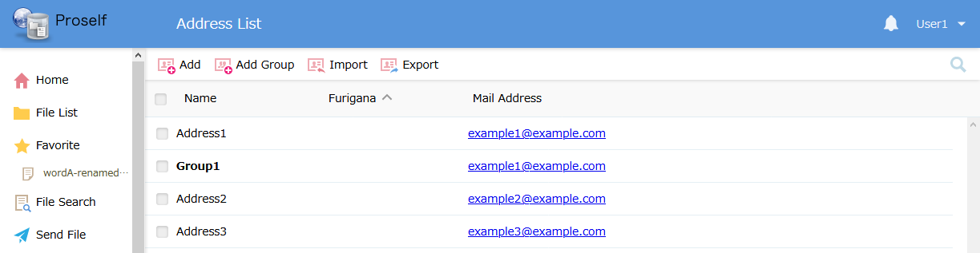
The Address List screen

Export
You can export an address list in .CSV format.
Click “Export” at the top of the screen.

The Address List screen

The Export Address dialog is shown. Click the “Export” button.
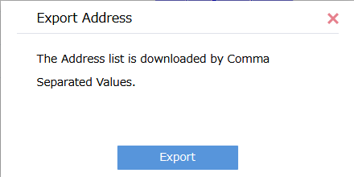
The Export Address dialog

The exported file is downloaded. You can open this file in a text editor, etc., to confirm the exported address list.
